**Practical Task 1:** Upload and Retrieve Files with Azure Blob Storage Use Azure Blob Storage for storing and retrieving files. Requirements:

1. Create a new storage account in Azure.



2. Set up a Blob container named "my-container" with public access.

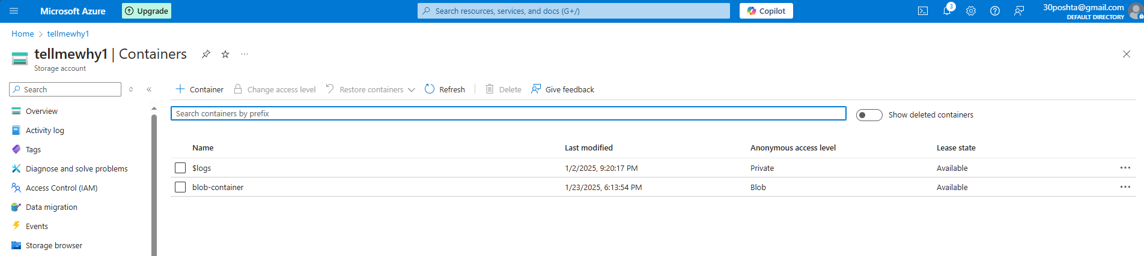

3. Upload a sample text file to the Blob container using the Azure portal.

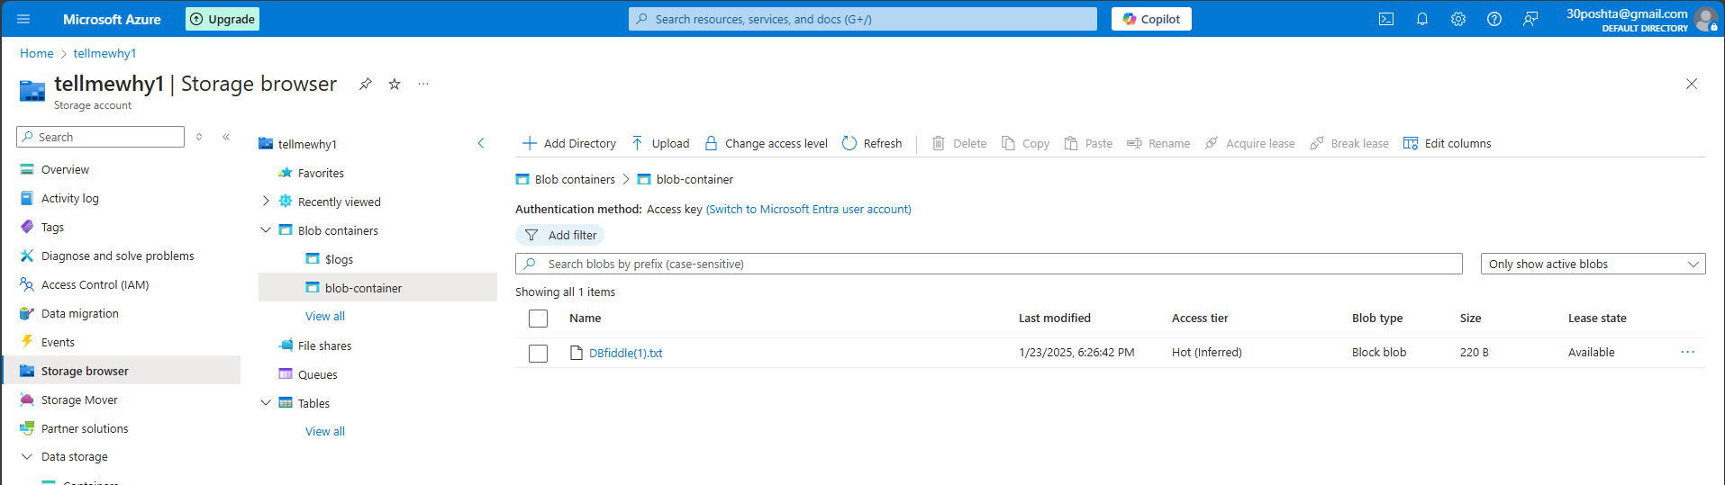

4. Download the uploaded file to verify successful retrieval.

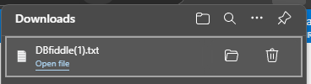

5. Use Azure Storage Explorer to manage and view blobs in your container.

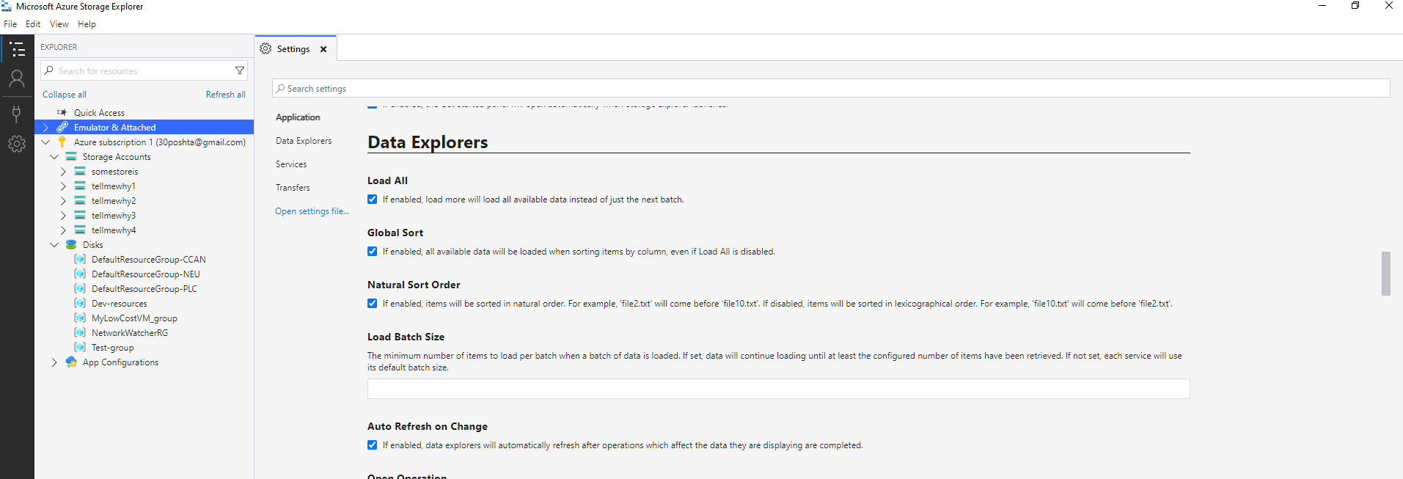 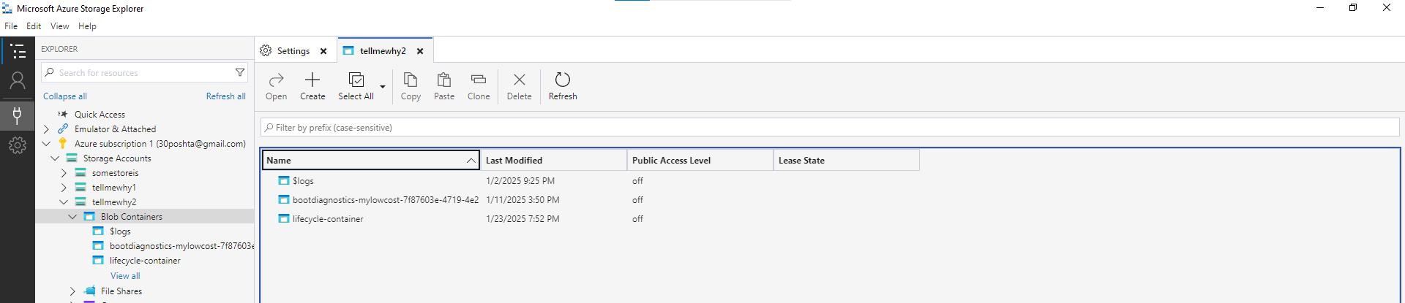

**Practical Task 2:** Lifecycle Management for Blob Storage Implement lifecycle management policies to optimize storage costs. Requirements:

1. Create a storage account and a Blob container named "lifecycle-container."

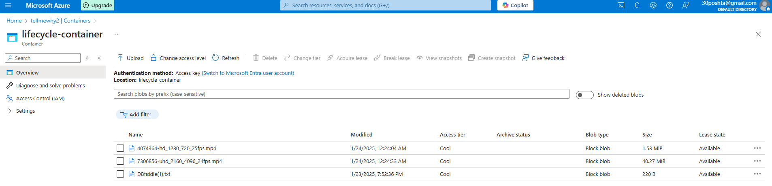

2. Upload multiple files of varying sizes to the container.



3. Create a lifecycle management policy to move blobs to the Cool tier after 30 days and delete blobs older than 90 days. 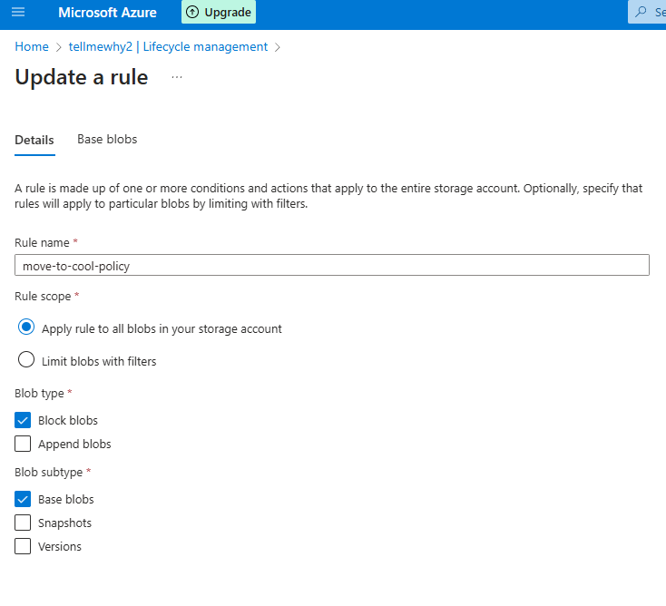

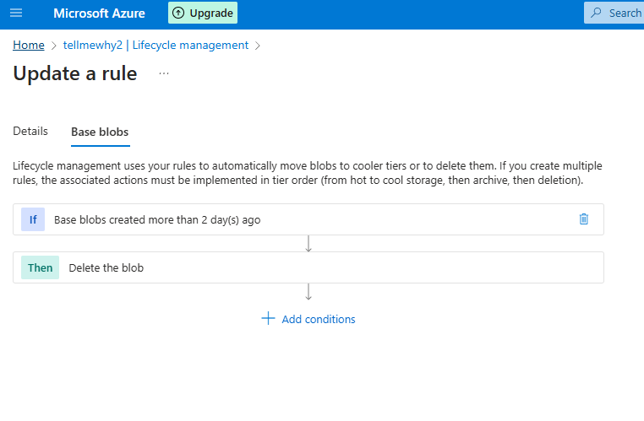

4. Simulate policy execution by manually testing with different file creation timestamps.

*Used 1 and 2 days for actions instead*

5. Verify that blobs are moved or deleted according to the policy.

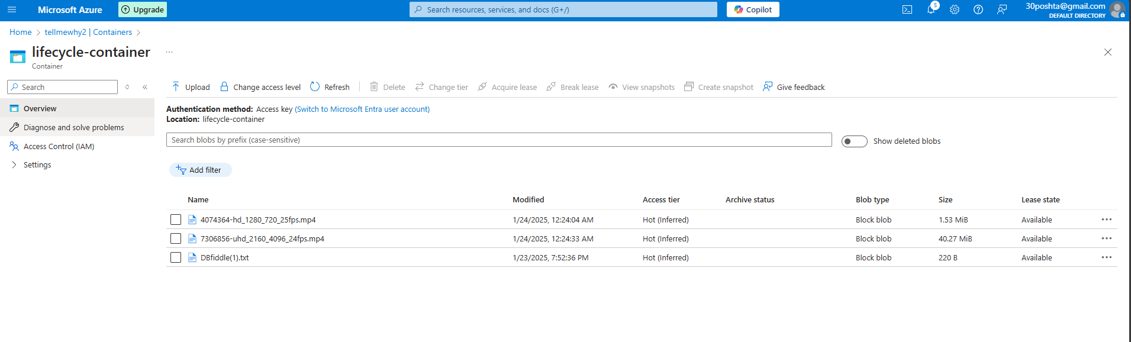

**Practical Task 3:** Implementing an Azure Queue for Message Storage Create and manage an Azure Queue to store and process messages. Requirements:

1. Create a storage account and enable the Queue service.

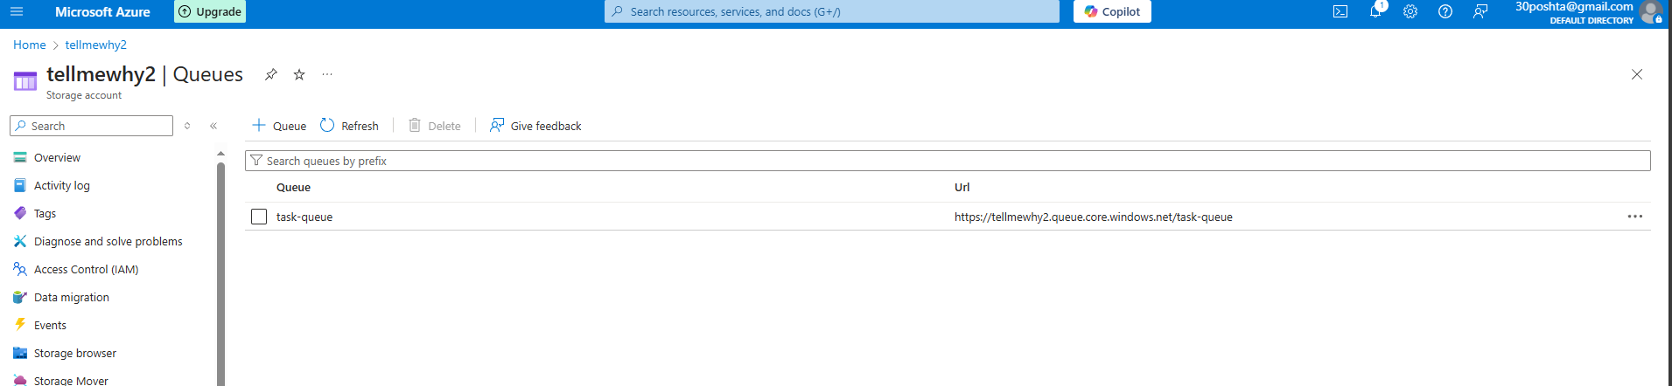

2. Create a queue named "task-queue." 

3. Use Azure Storage Explorer or the Azure portal to add messages to the queue. 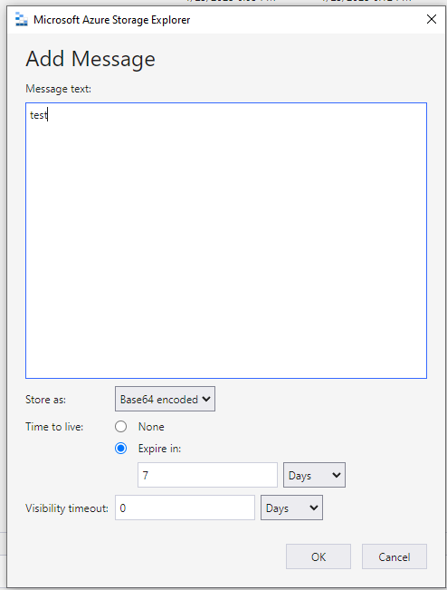

4. Retrieve and process messages directly using Azure Storage Explorer or the Azure portal interface.

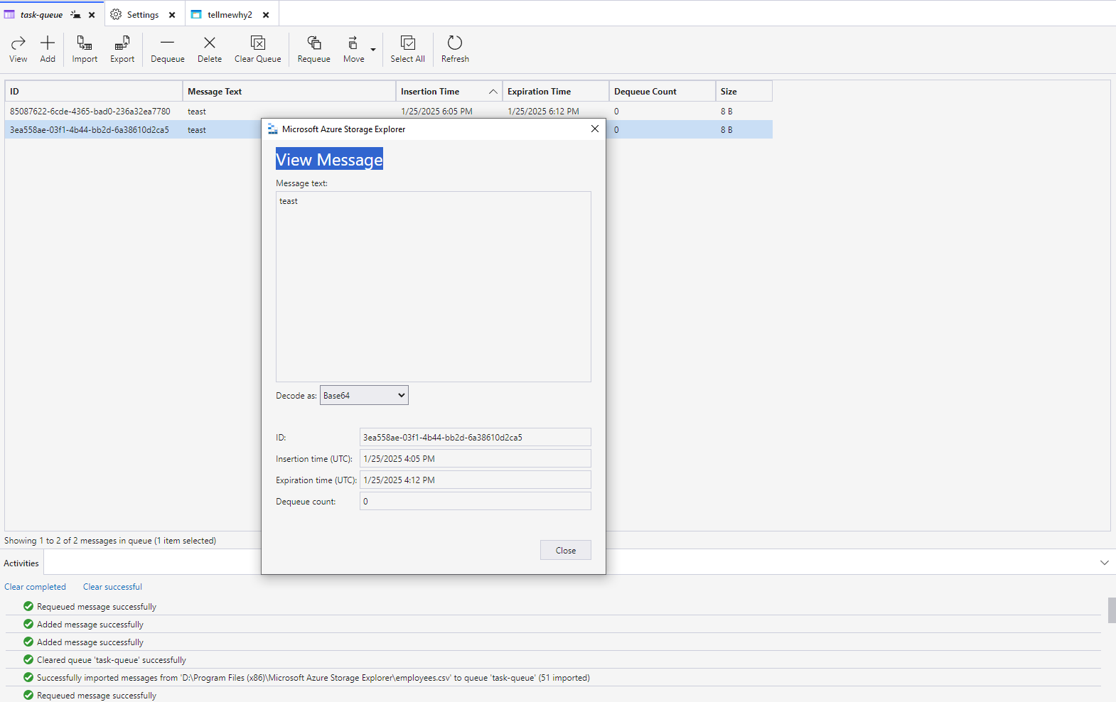

5. Verify that processed messages are removed from the queue manually.

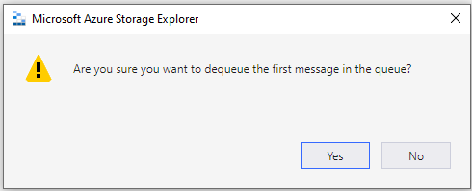 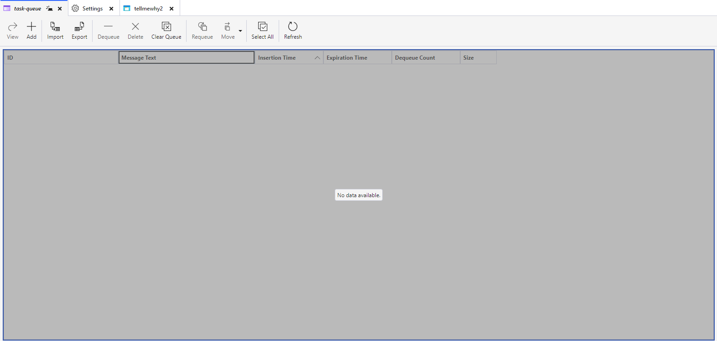

**Practical Task 4:** Configuring Azure File Share and Mounting on a Local Machine Set up and access Azure File Storage for shared file access. Requirements:

1. Create a storage account and set up an Azure File Share.

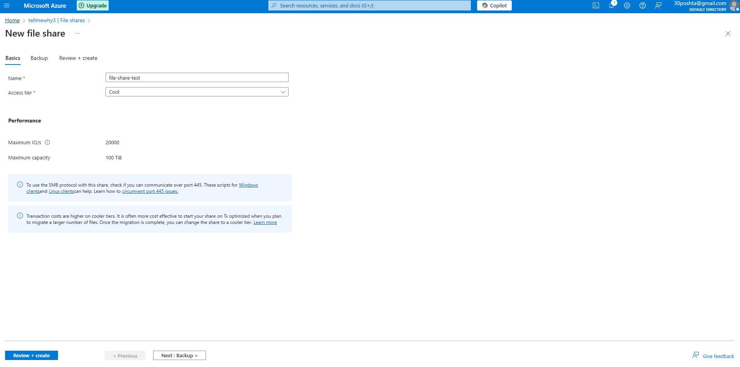

2. Upload a file to the file share using the Azure portal. –

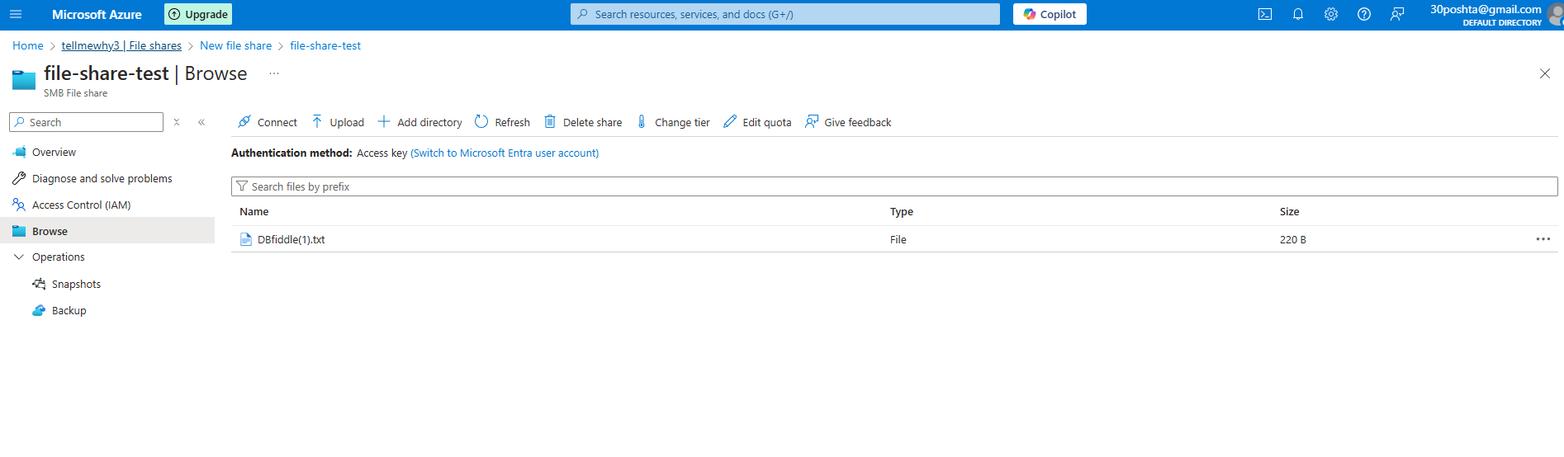

3. Generate a connection script for Windows or Linux and use it to mount the file share on your local machine.

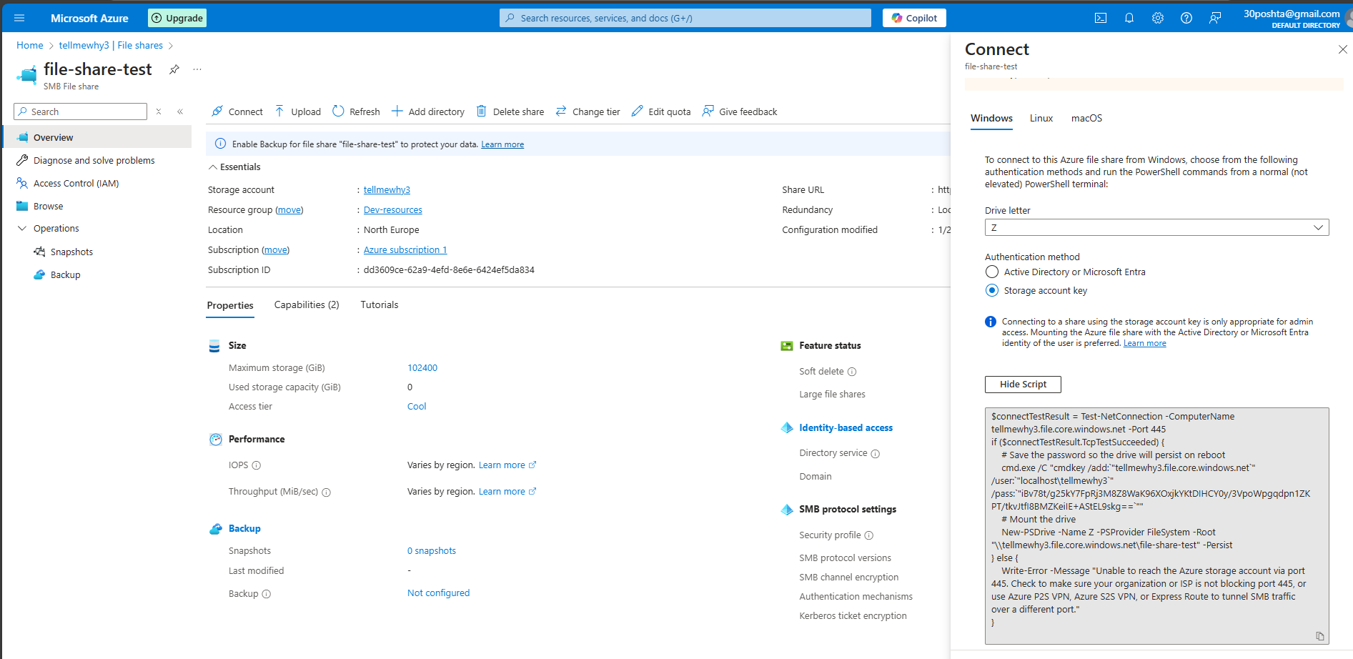

4. Verify the mounted file share and ensure it displays the uploaded file.

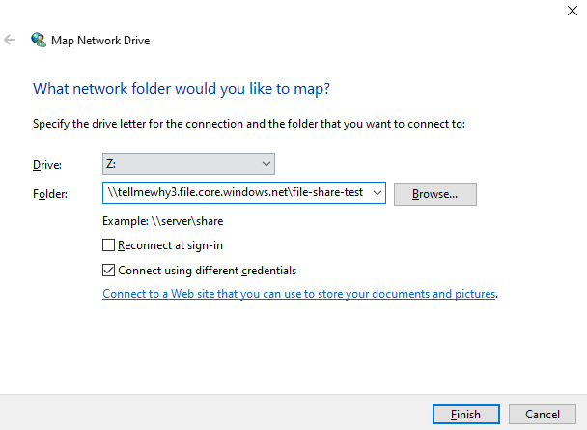  
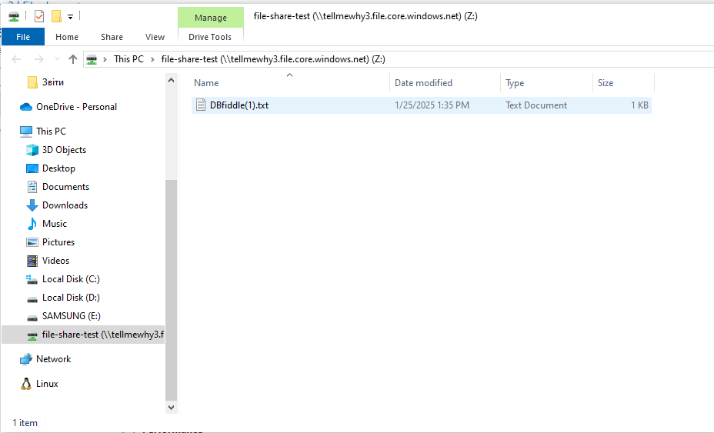

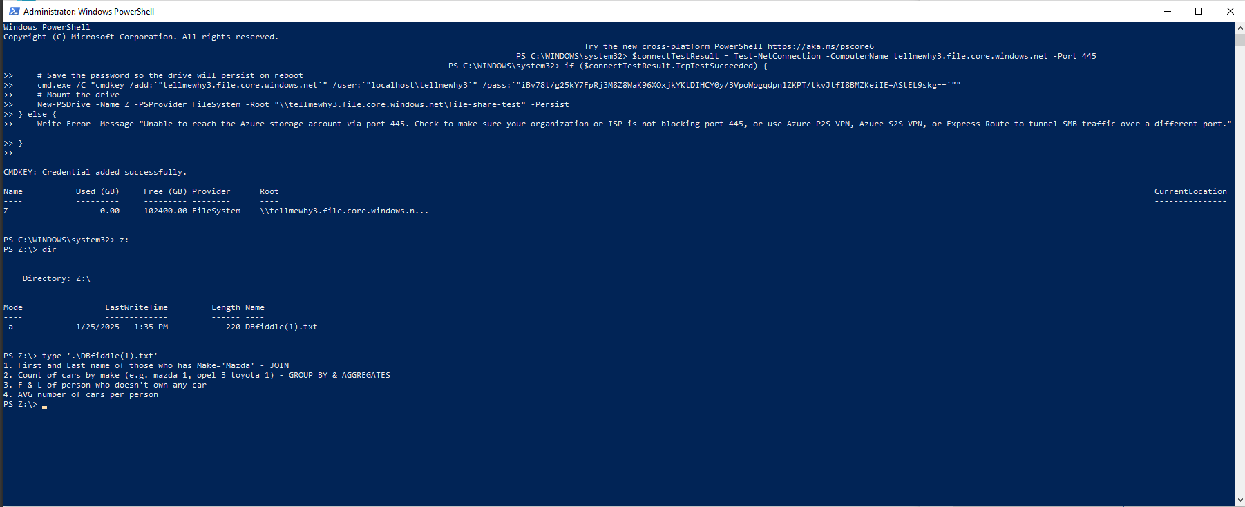

5. Add another file to the file share from the local machine and confirm it reflects in Azure.

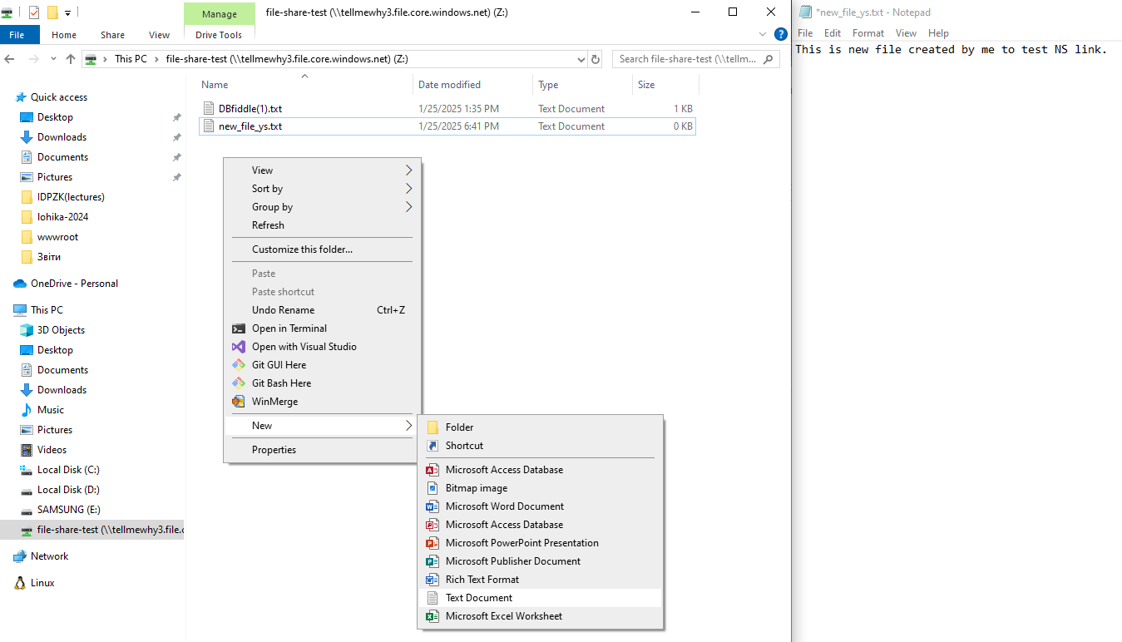  
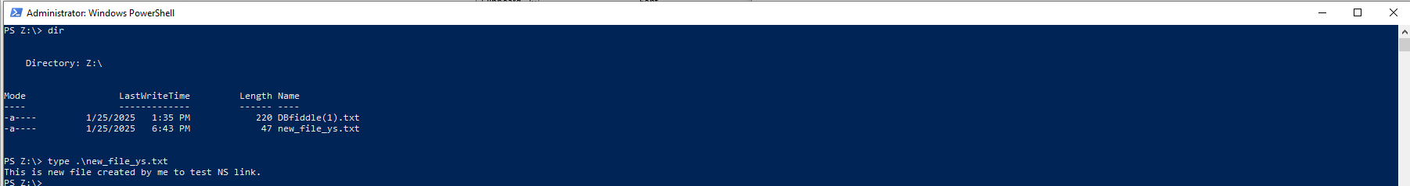

**Practical Task 5:** Storing and Querying Data with Azure Table Storage Set up and use Azure Table Storage for structured data. Requirements:

1. Create a storage account and enable the Table service.

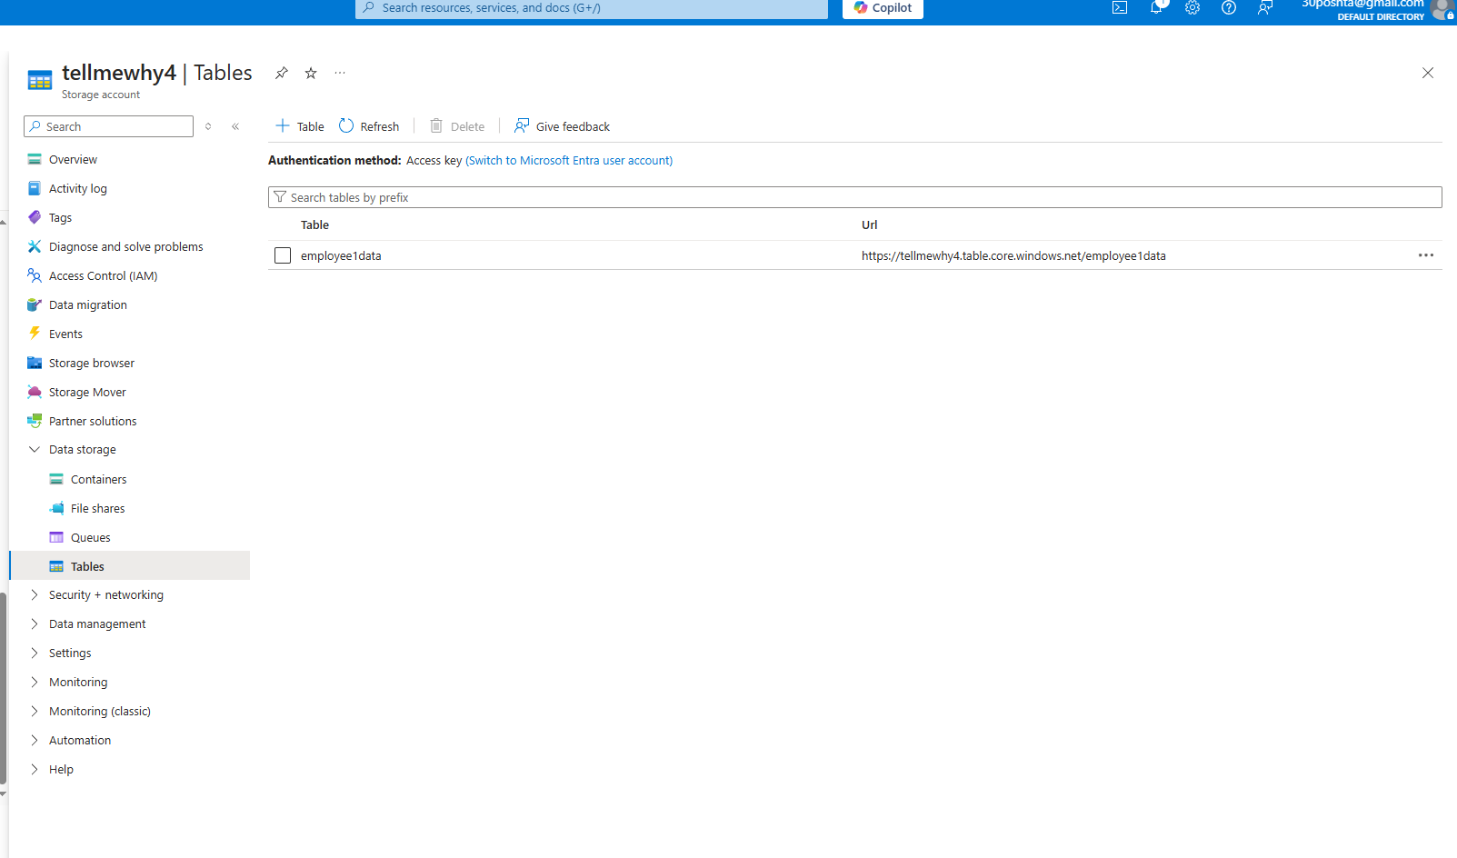

2. Create a table named "employee-data".



3. Add sample data (e.g., employee IDs, names, and roles) to the table using Azure Storage Explorer or Azure CLI. 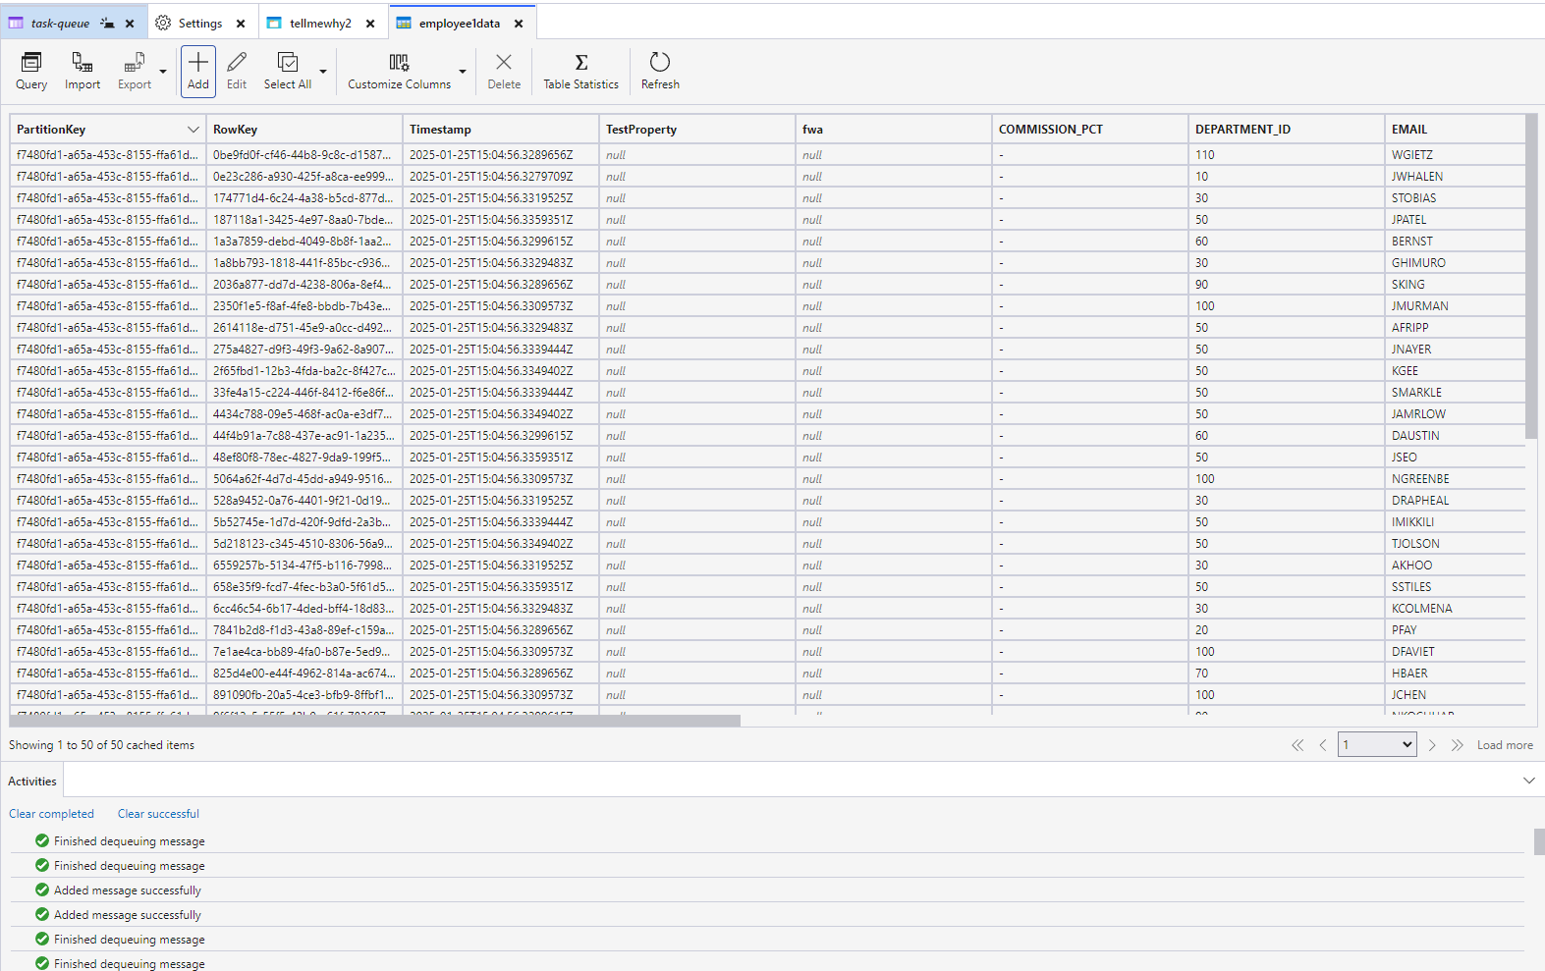

4. Query the table for specific data using filters (e.g., "Role = Developer").

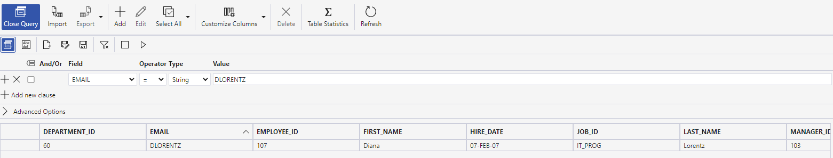

5. Delete specific entries from the table and verify the changes.

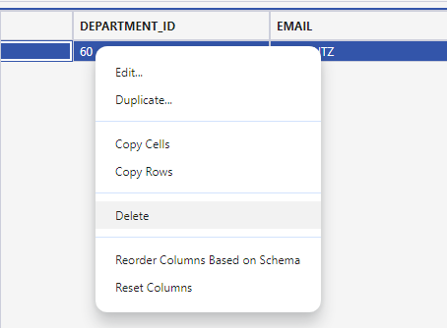

**Practical Task 6:** Configuring Shared Access Signatures (SAS) for Secure Access Secure Azure Storage services using SAS tokens. Requirements:

1. Create a storage account with Blob, File, Queue, and Table services enabled.

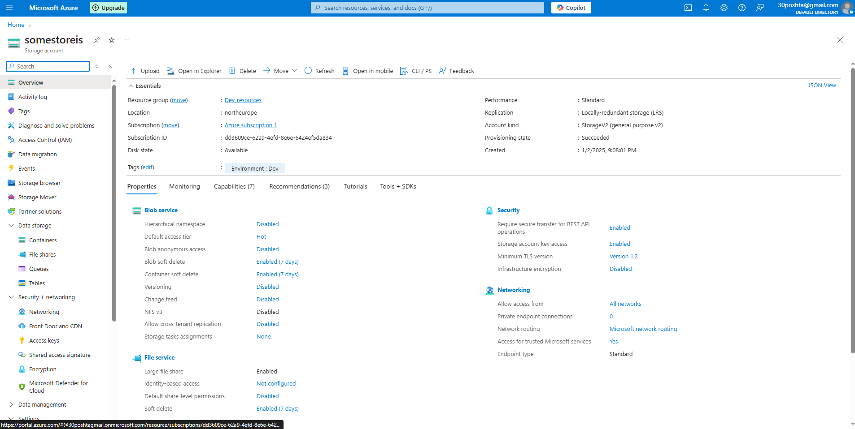

2. Generate a Shared Access Signature (SAS) token for Blob storage with limited permissions (e.g., read-only access).

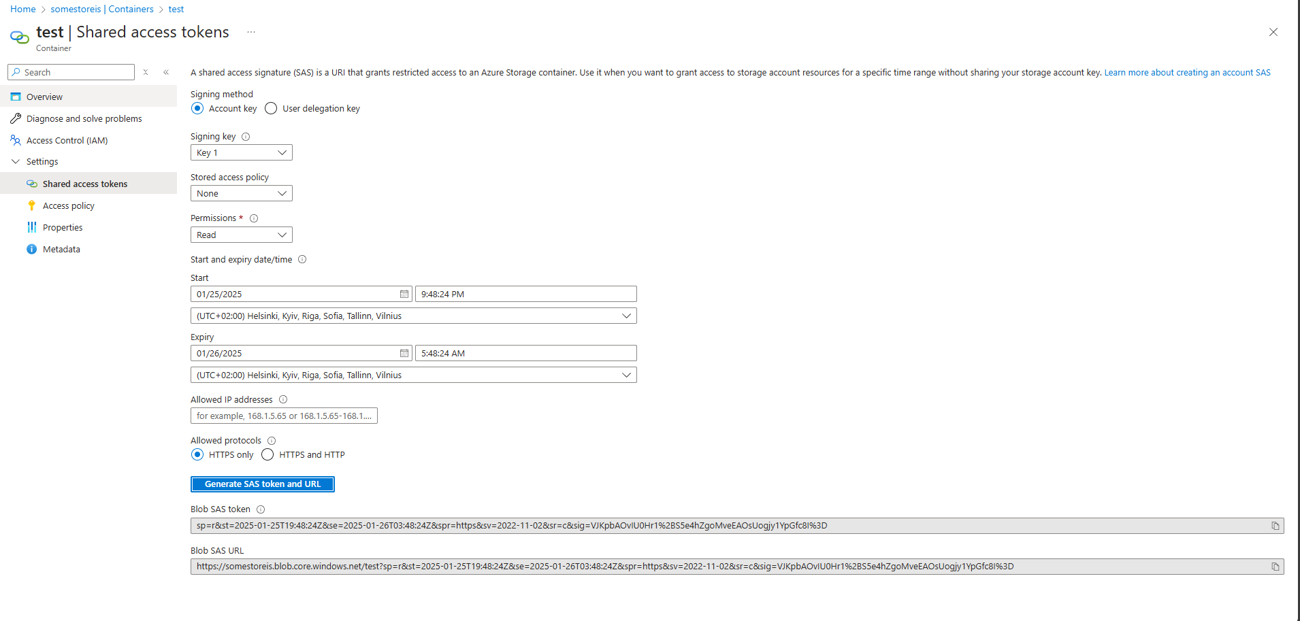

3. Share the SAS token URL and verify access to the Blob container with the token.

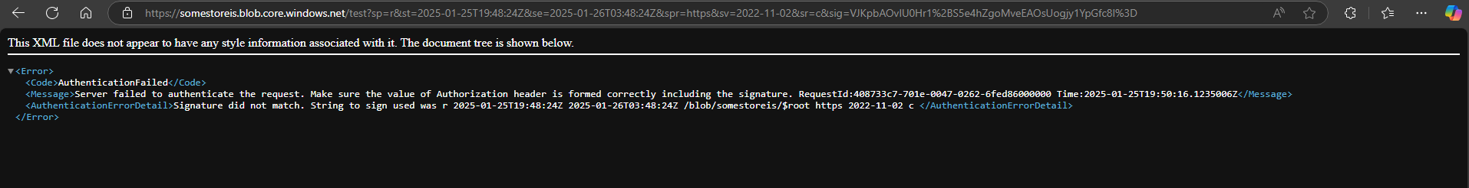

It needs specific file

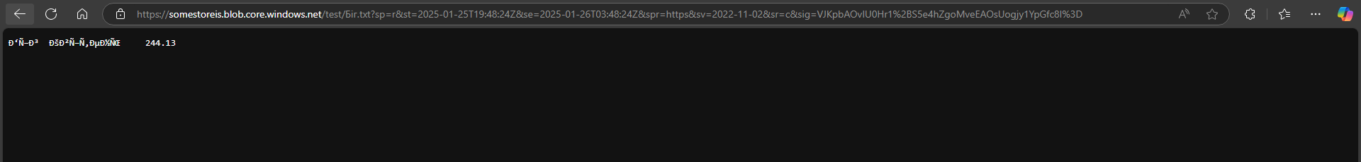



4. Repeat the process for File, Queue, and Table services with different permissions. 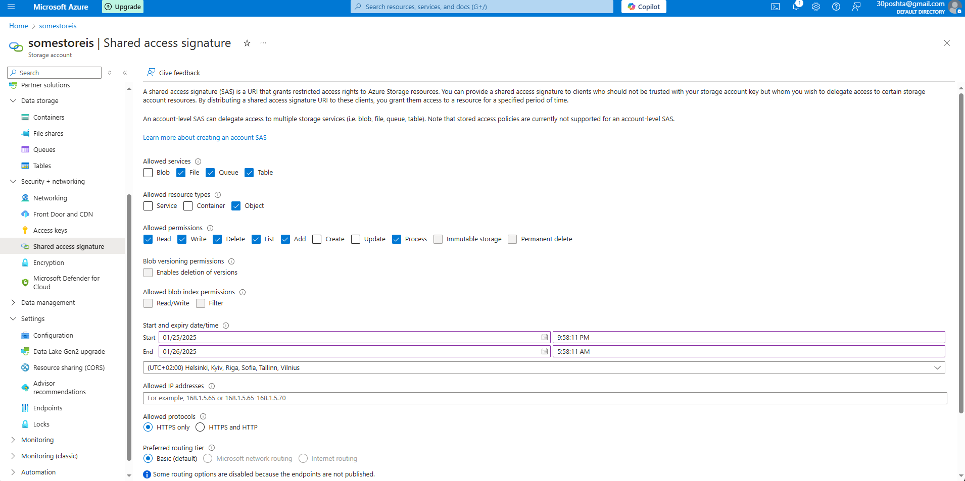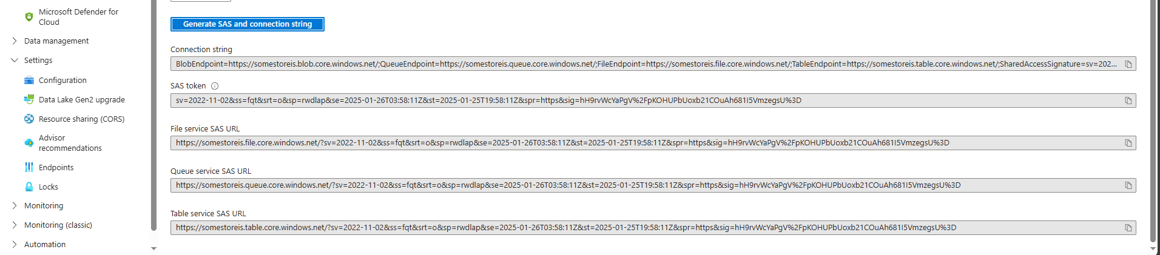

5. Analyze the security implications of SAS tokens and expiry times.

**Practical Task 7:** Implementing Security Best Practices with Azure RBAC and Managed Identities Securely manage access to Azure resources and integrate services using Managed Identities. Requirements:

1. Configure Azure RBAC for a Storage Account:

o Create a storage account named "secure-storage". 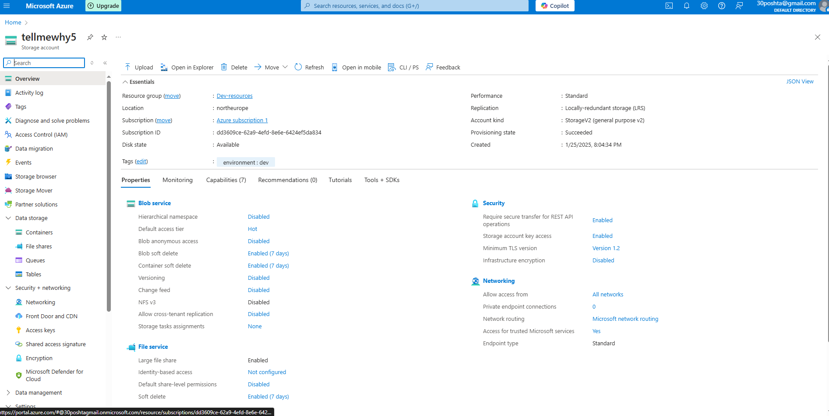

o Add a user or service principal with Storage Blob Data Contributor role.

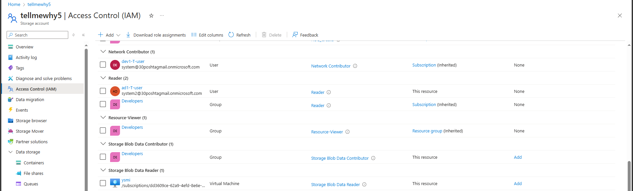

o Verify that the user or service principal can upload and download blobs to the account.

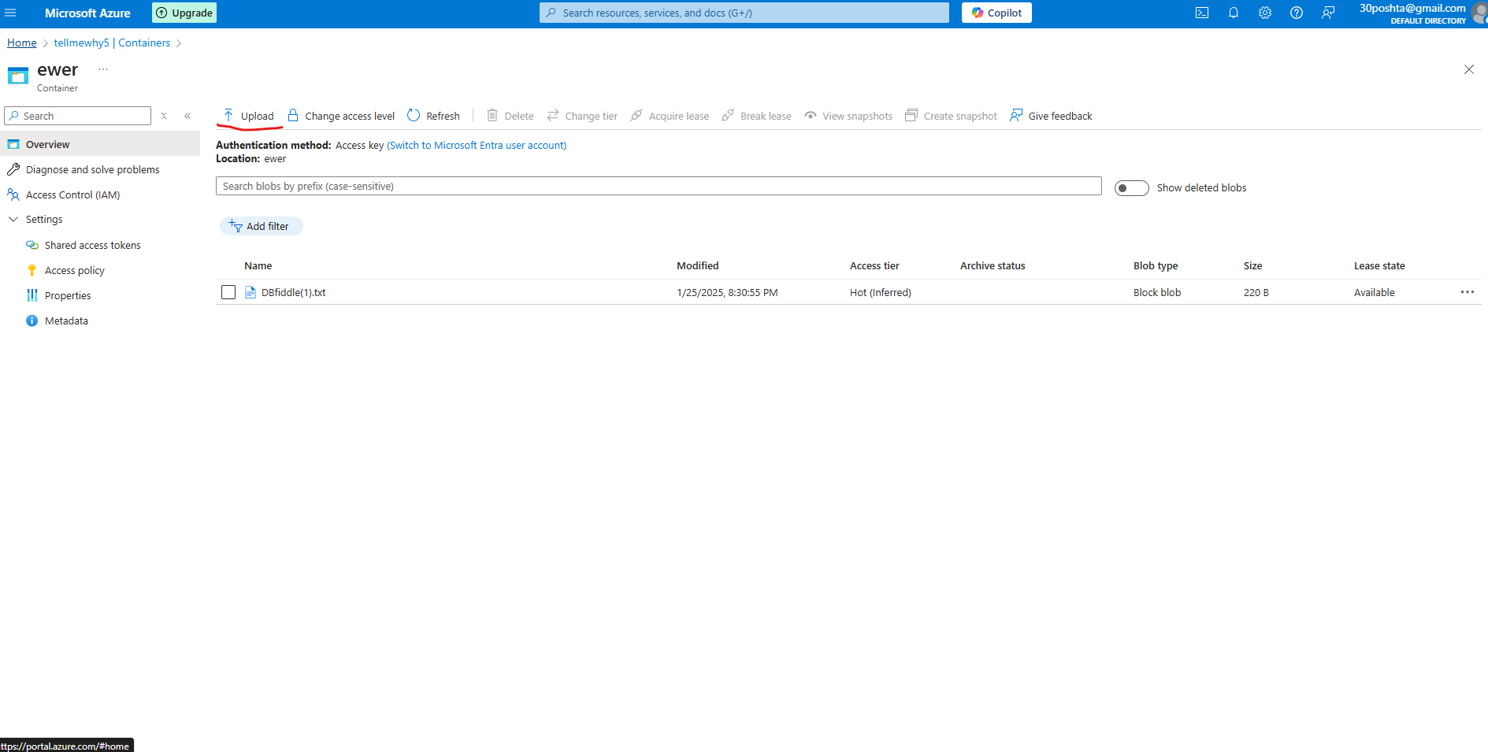

o Attempt access with an unauthorized user and verify access is denied. 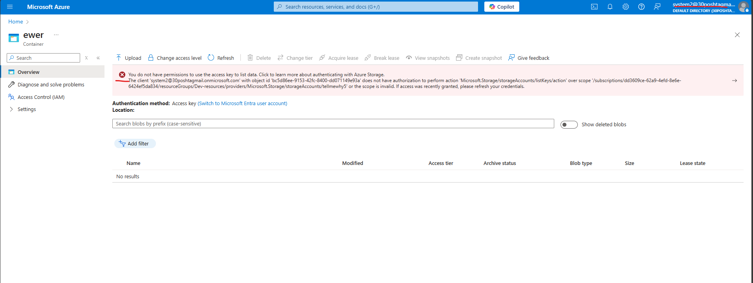

2. Set Up a Managed Identity for an Azure Virtual Machine:

o Create an Azure Virtual Machine (VM) with a system-assigned Managed Identity enabled. 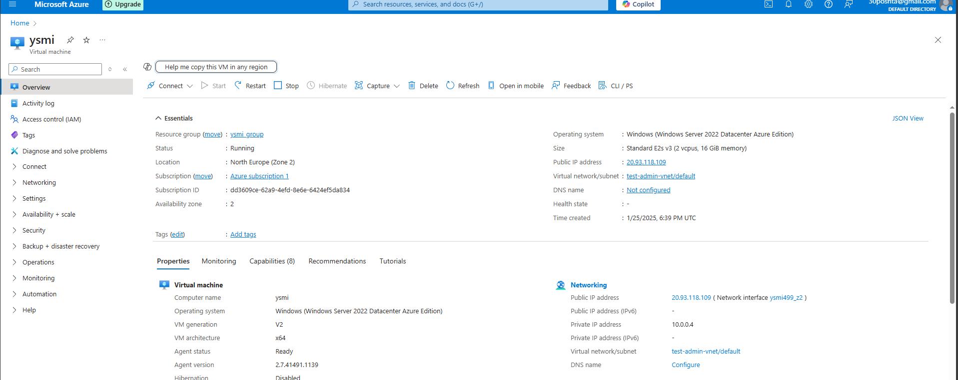

o Assign the Storage Blob Data Reader role to the Managed Identity for "securestorage".

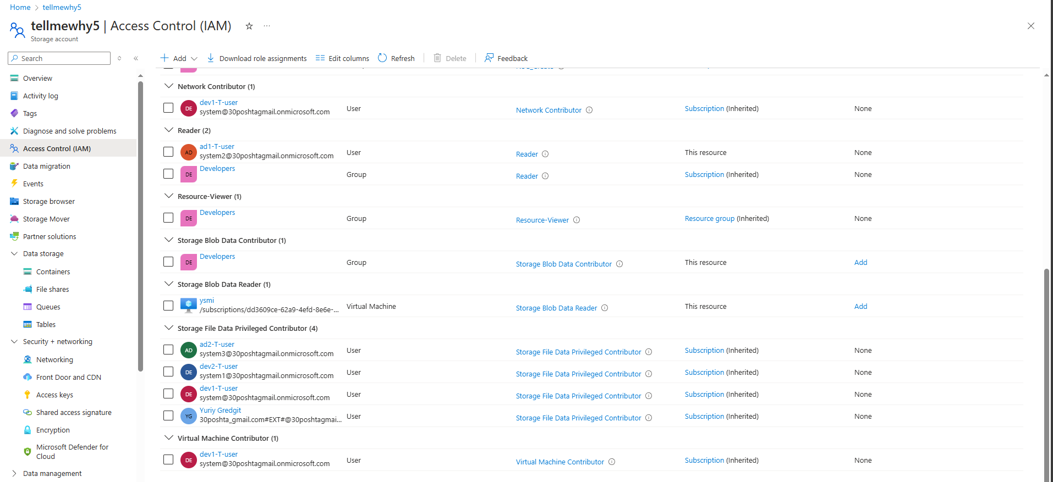

o Connect to the VM and verify that the Managed Identity can access blob data using Azure CLI or a pre-installed script.

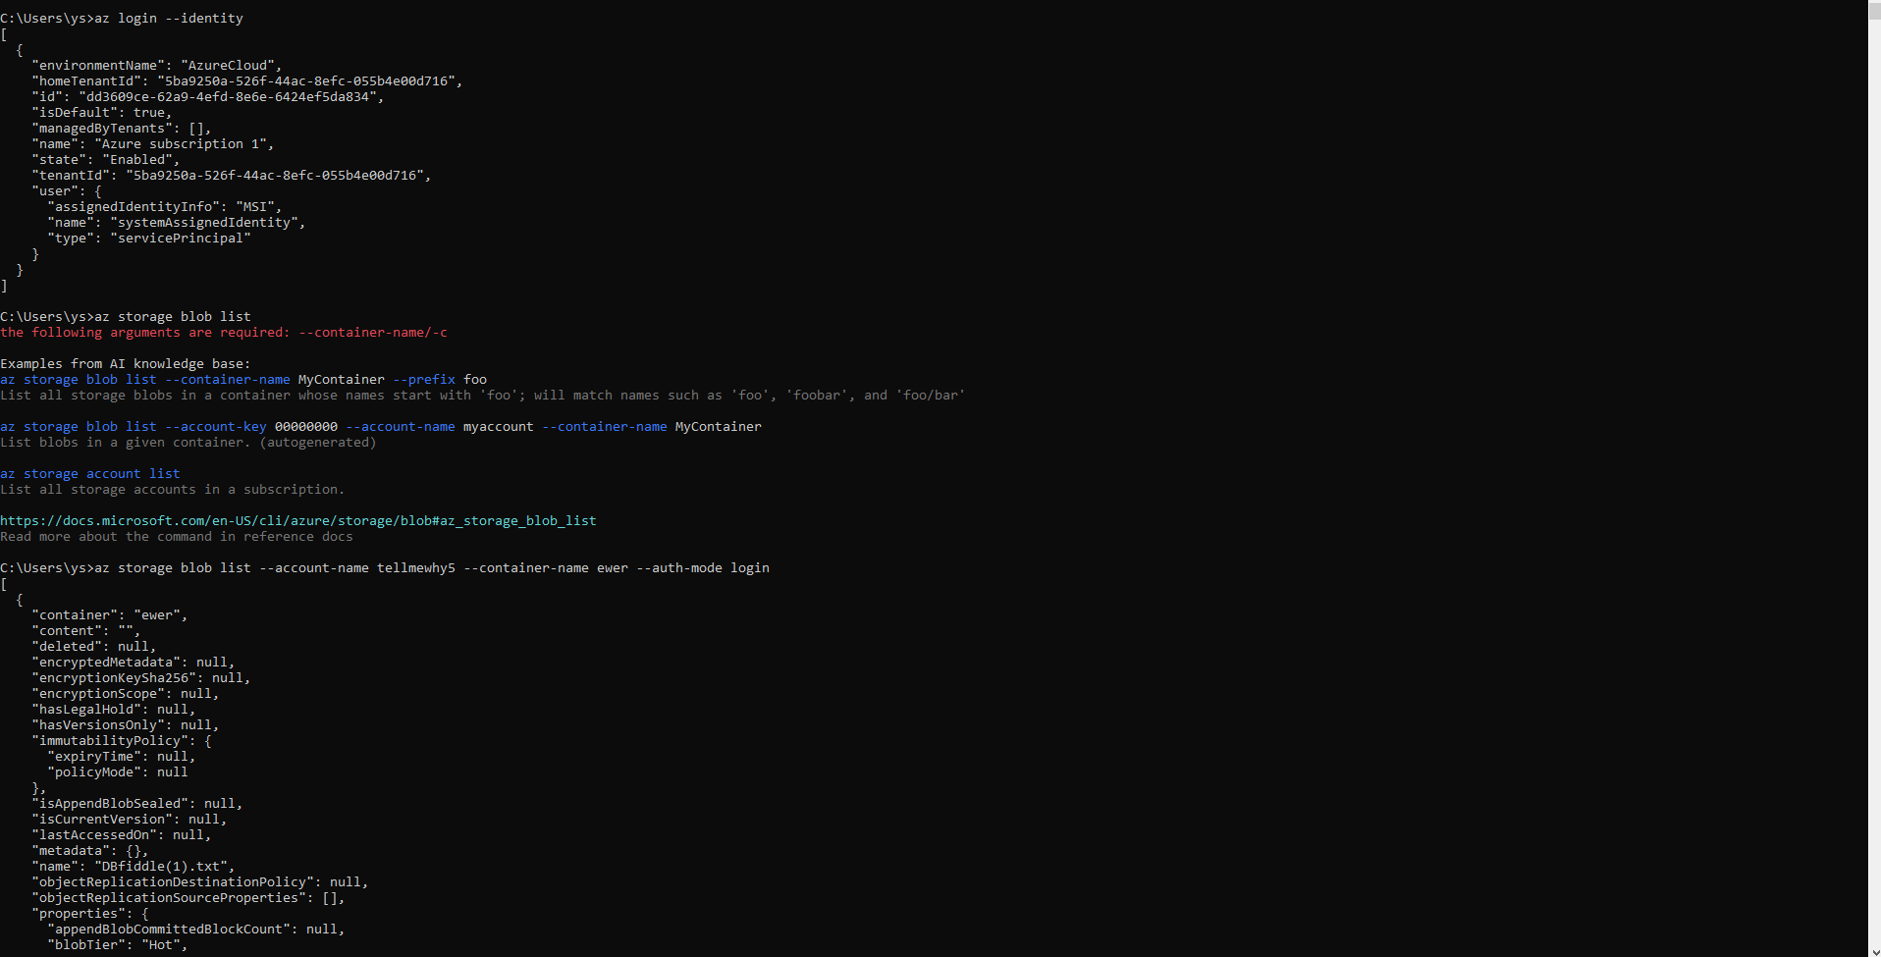

**Practical Task 8:** Creating and Querying an Azure SQL Database Learn to create and query an Azure SQL Database using the Azure portal. Requirements:

1. Create an Azure SQL Database named "test-db" in a new logical SQL server.

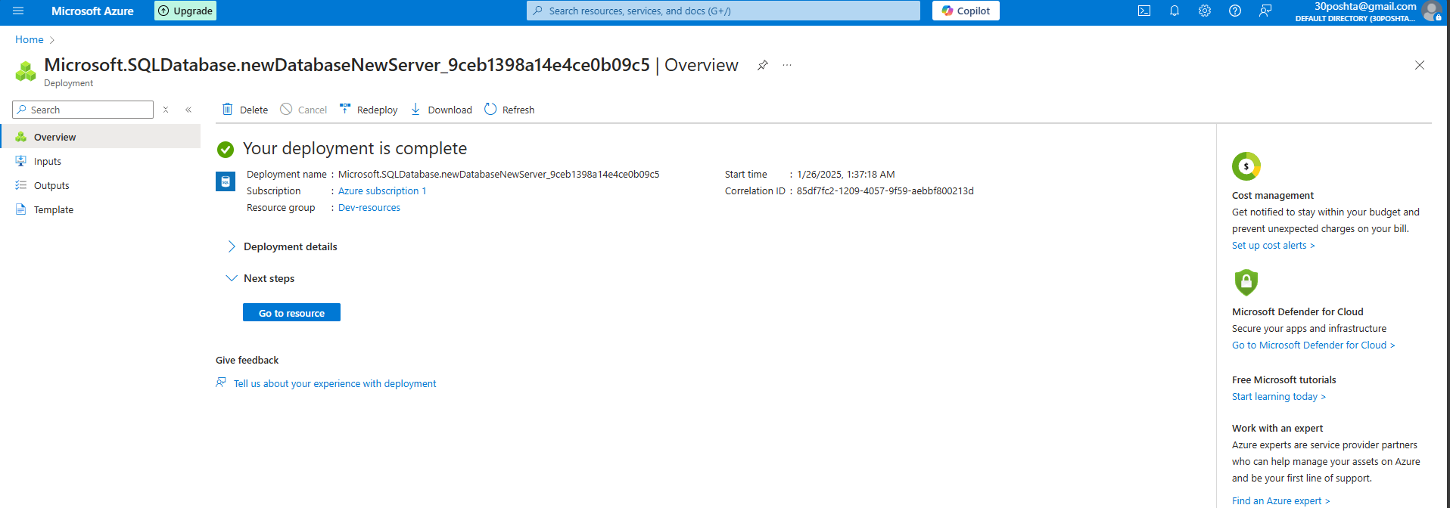

2. Set the pricing tier to the free tier for cost optimization.

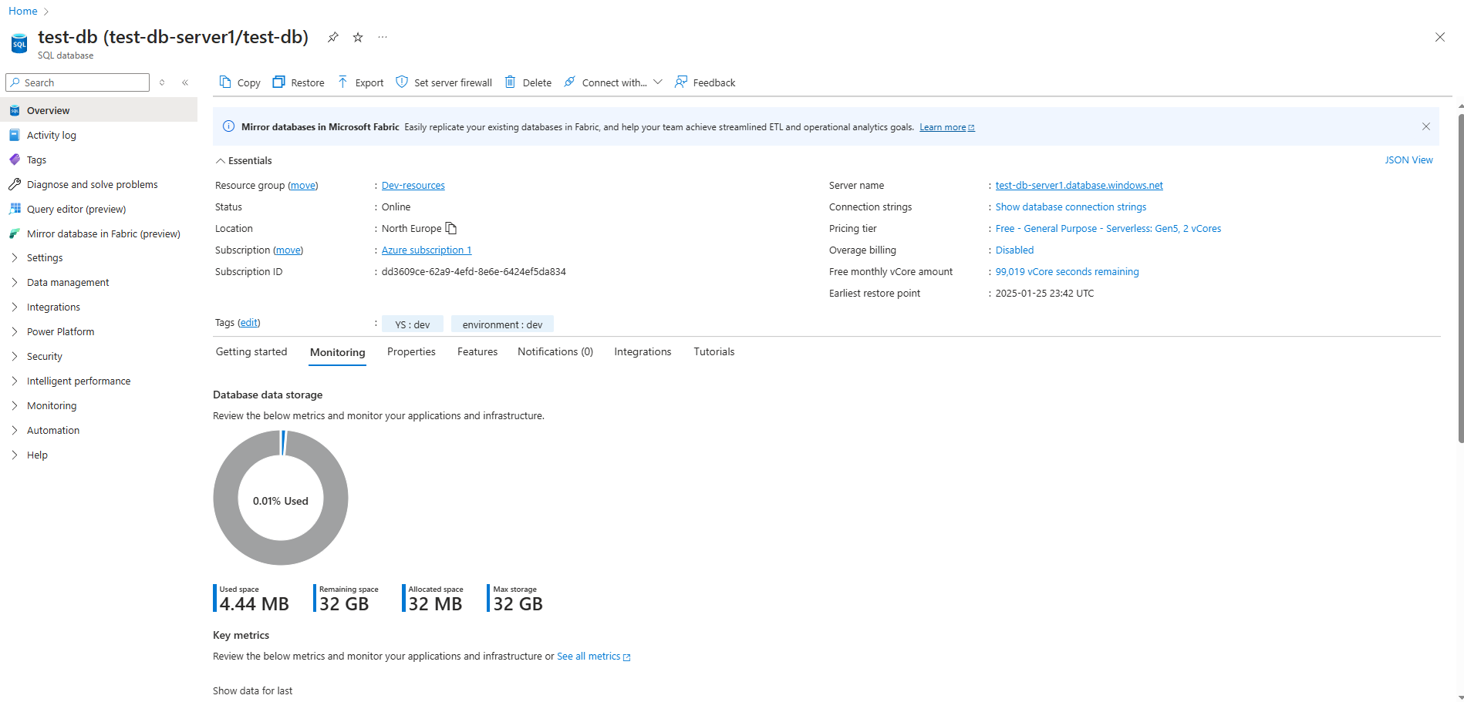

3. Use the Query Editor in the Azure portal to create a table named "Products" with columns for ID, Name, and Price. 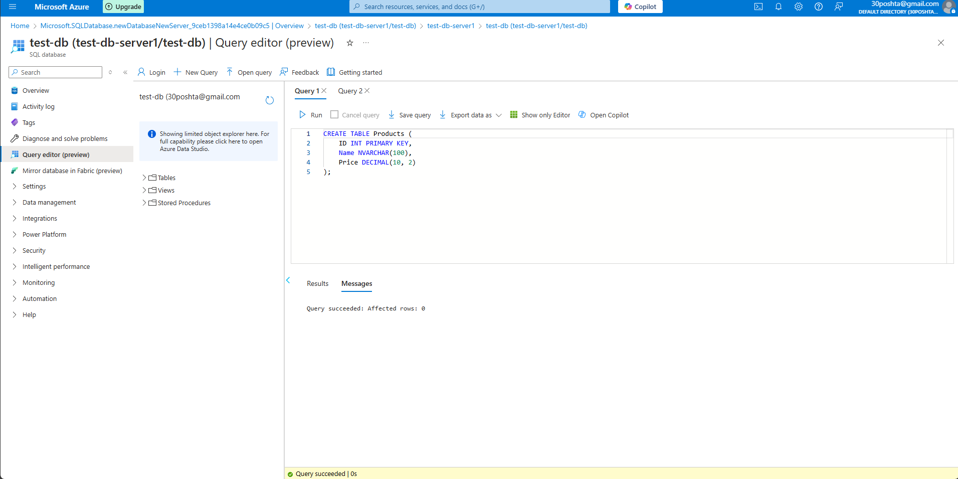

4. Insert a few sample records into the "Products" table using a SQL query.

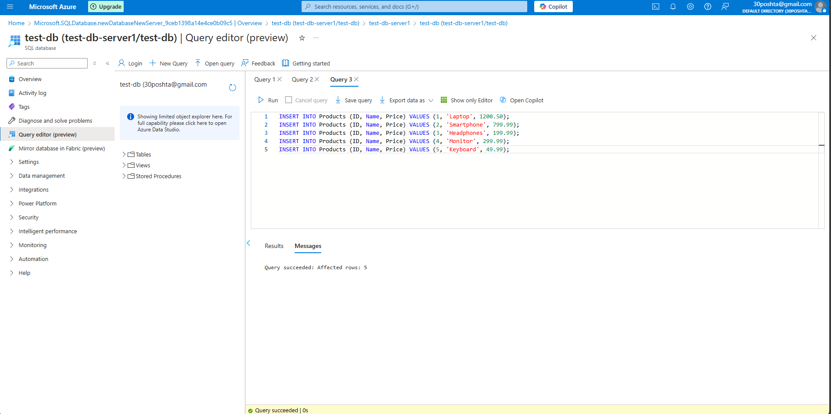

5. Query the table to display all records and verify the data.

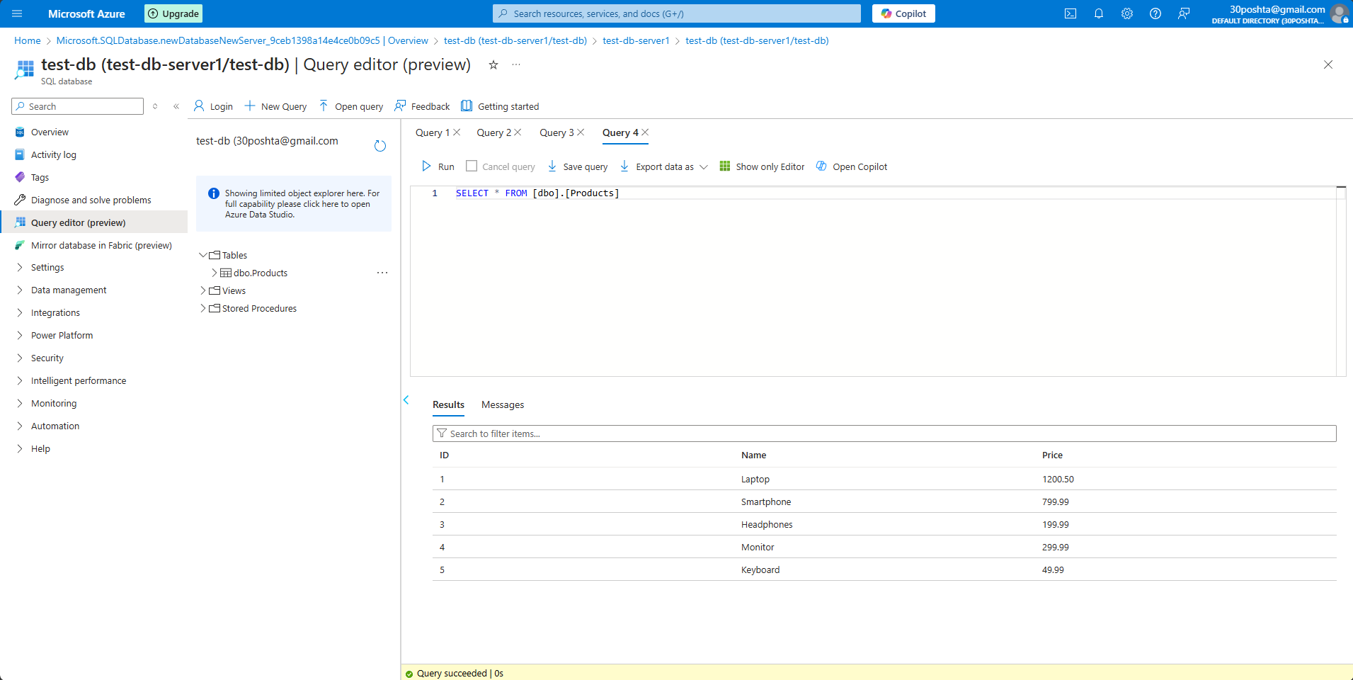

**Practical Task 9:** Deploying an Azure SQL Database with Automated Backup Configuration Set up an Azure SQL Database and configure automated backups. Requirements:

1. Create an Azure SQL Database in a new or existing resource group. 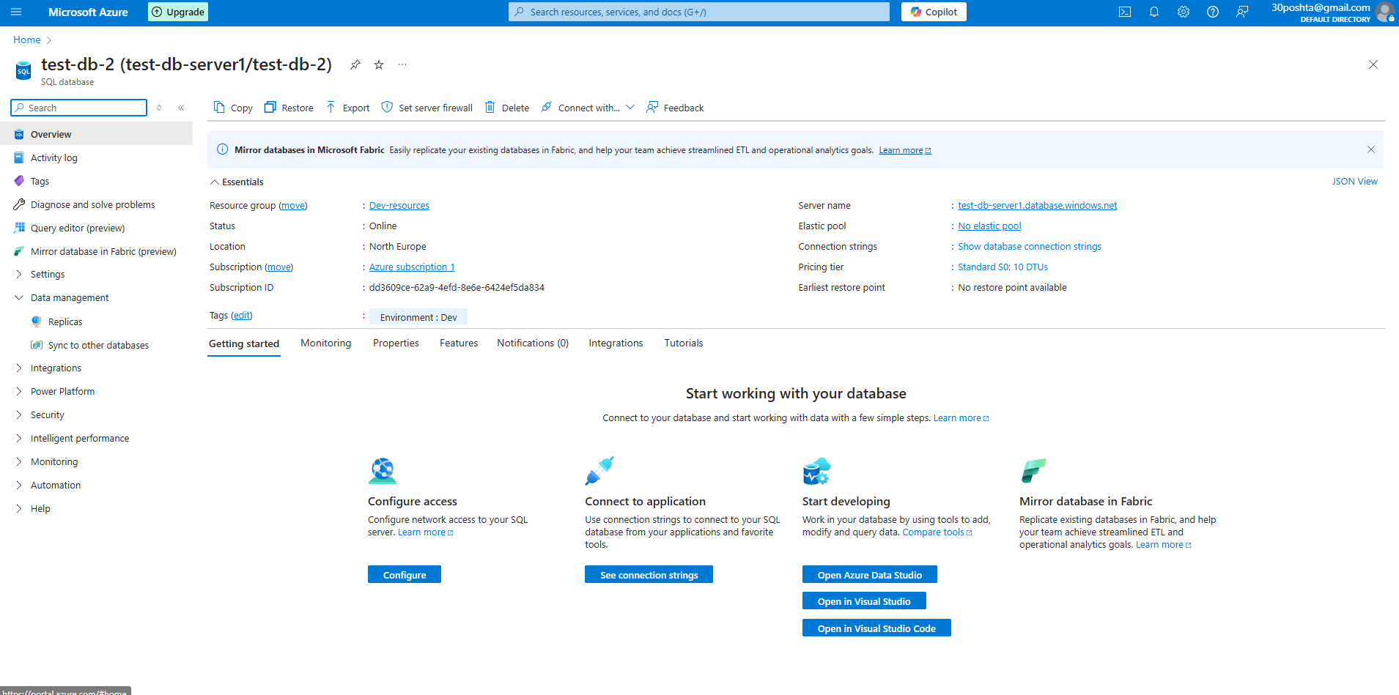

2. Choose the desired service tier (e.g., Basic or General Purpose). 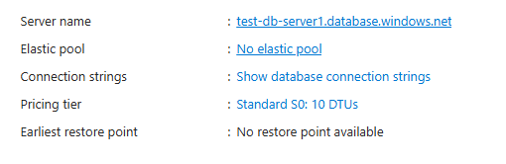

3. Enable and configure long-term backup retention for the database.

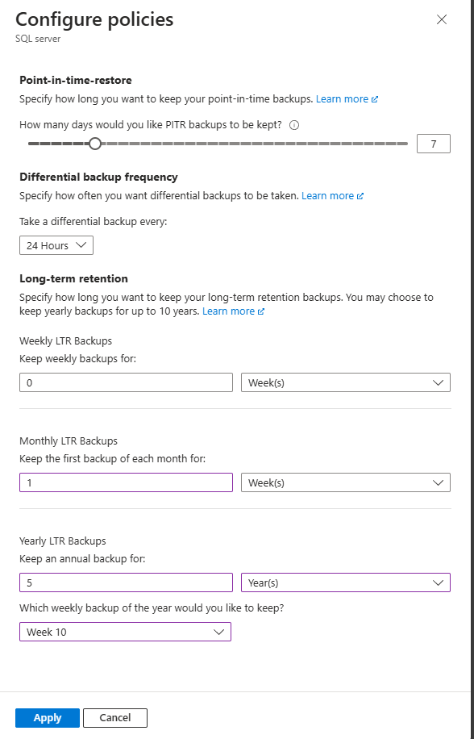

4. Use the Azure portal to verify backup settings and review available restore points.

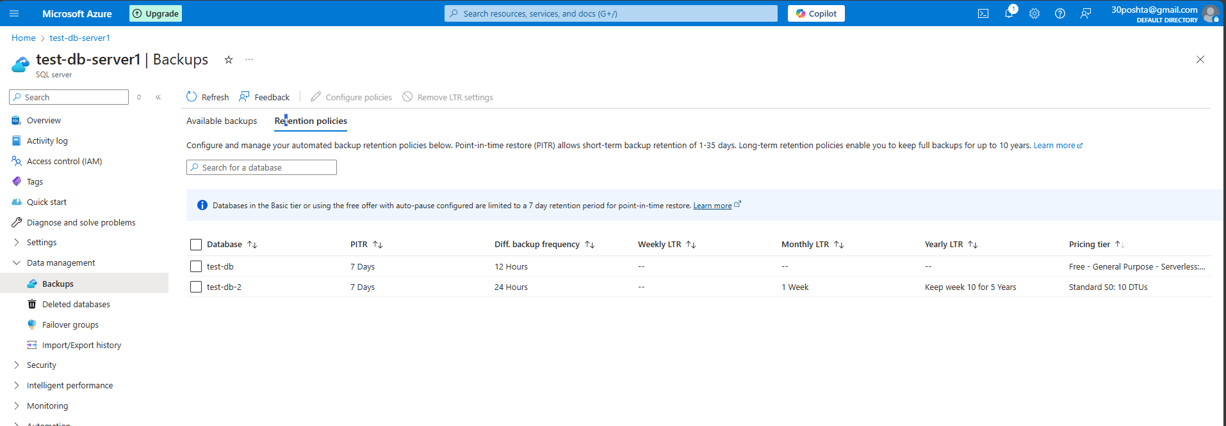

5. Test the restore process by creating a new database from a backup.

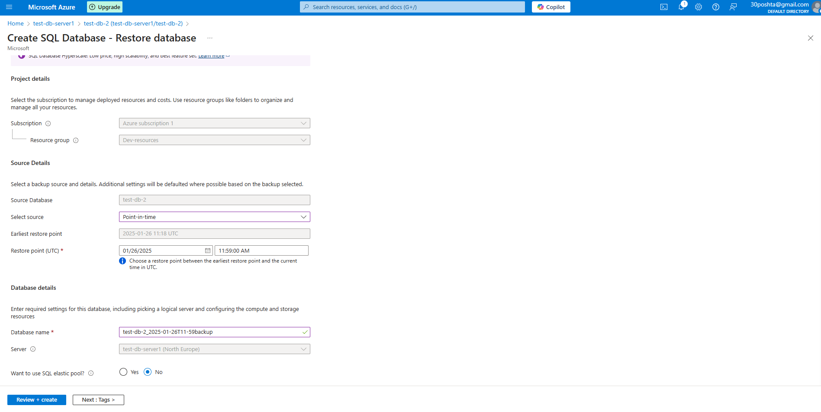 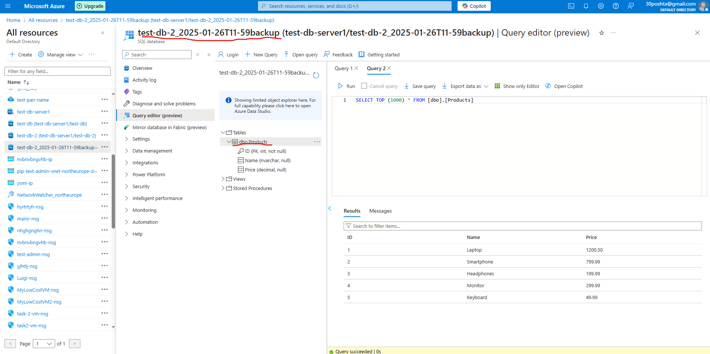 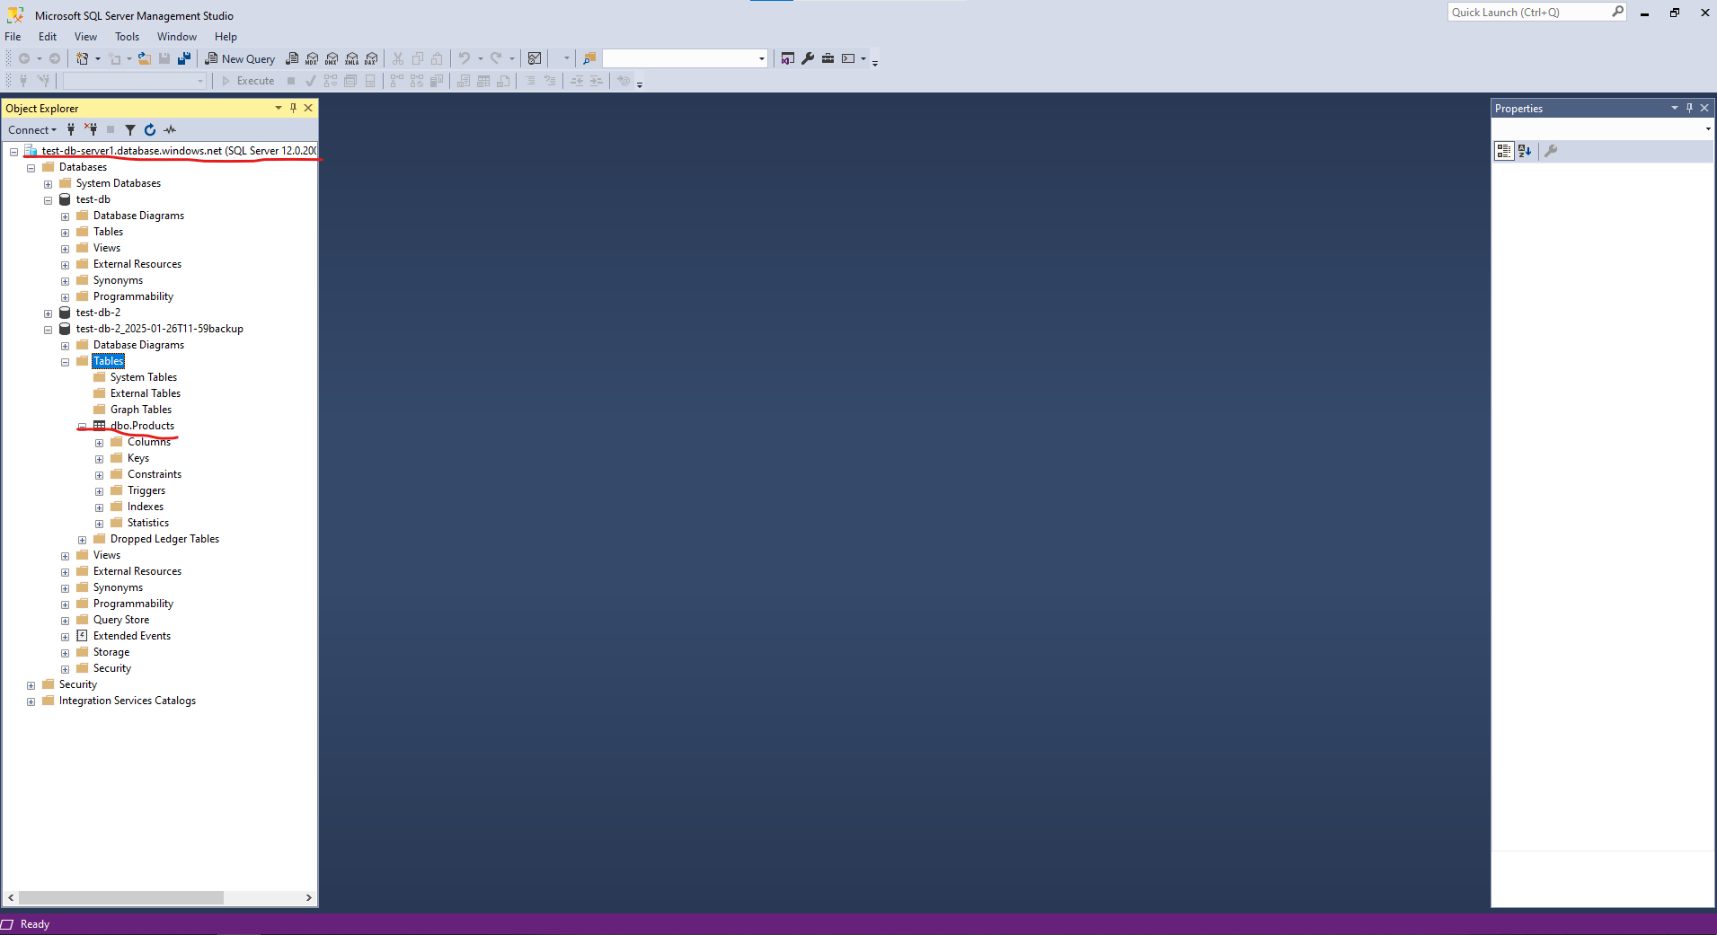

**Practical Task 10:** Getting Started with Cosmos DB Set up and explore Cosmos DB by creating a database, managing data, querying, and testing key features like consistency and global distribution. Requirements:

**1. Create a Cosmos DB Account:**

o Create a new Cosmos DB account in the Azure portal using the Core (SQL) API.

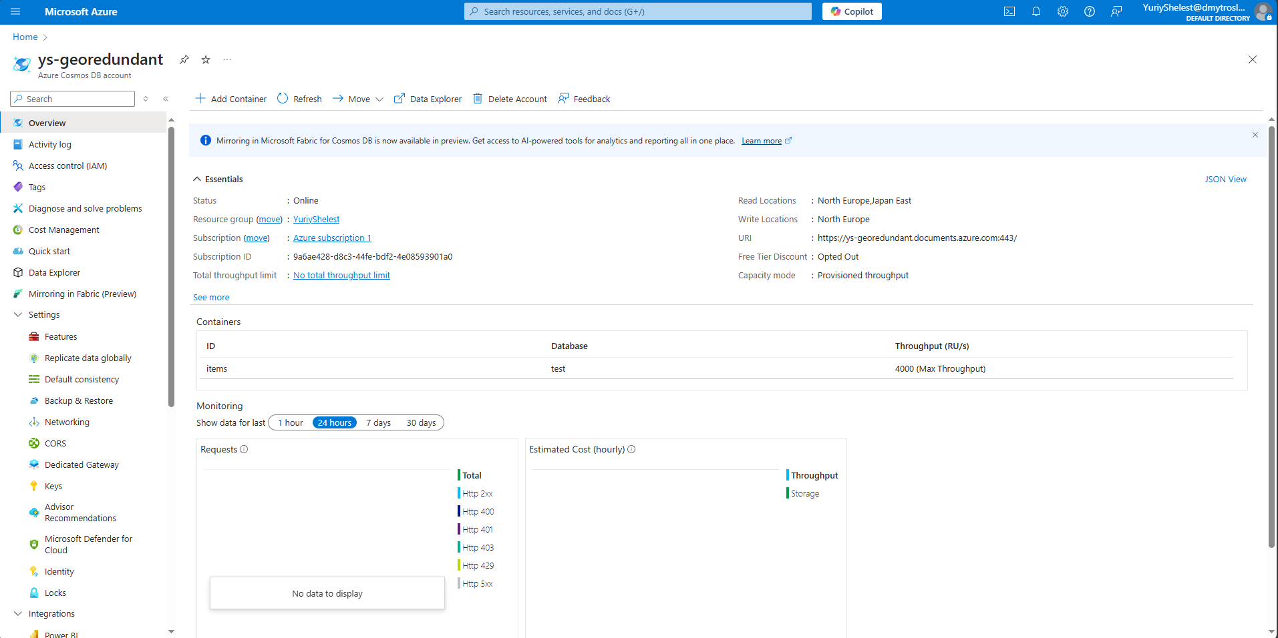

o Select a region for the account and use the default settings.



o Review key features like throughput, consistency levels, and global distribution.



o Note down the primary and secondary keys for the account. 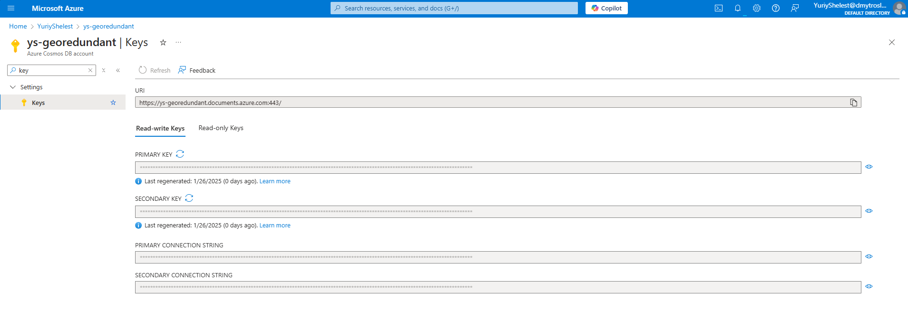

**2. Set Up a Database and Container:**

o Create a database named "SampleDB" in the Cosmos DB account.

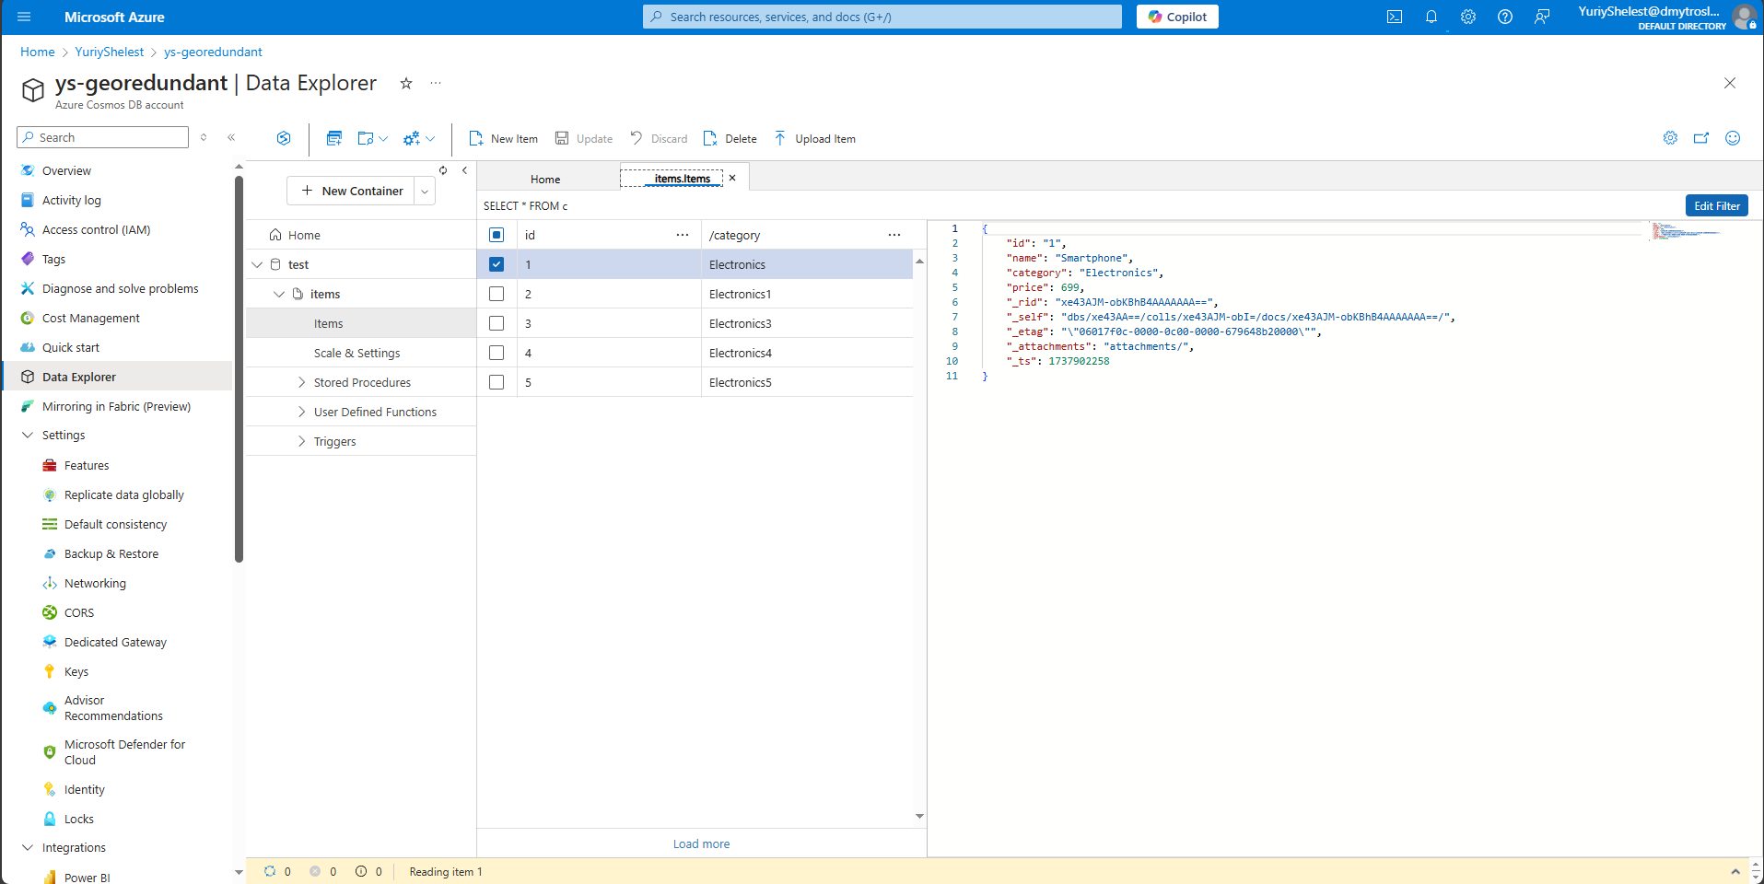

O Add a container named "Items" with the partition key set to /category.



o Use the default throughput settings for the database and container.

**3. Insert Data Using Data Explorer:**

o Open the Data Explorer in the Azure portal.



o Insert at least three sample JSON documents into the "Items" container. Example:

{

"id": "1",

"name": "Smartphone",

"category": "Electronics",

"price": 699

} 

o Verify that the documents are successfully added and visible in the Data Explorer. 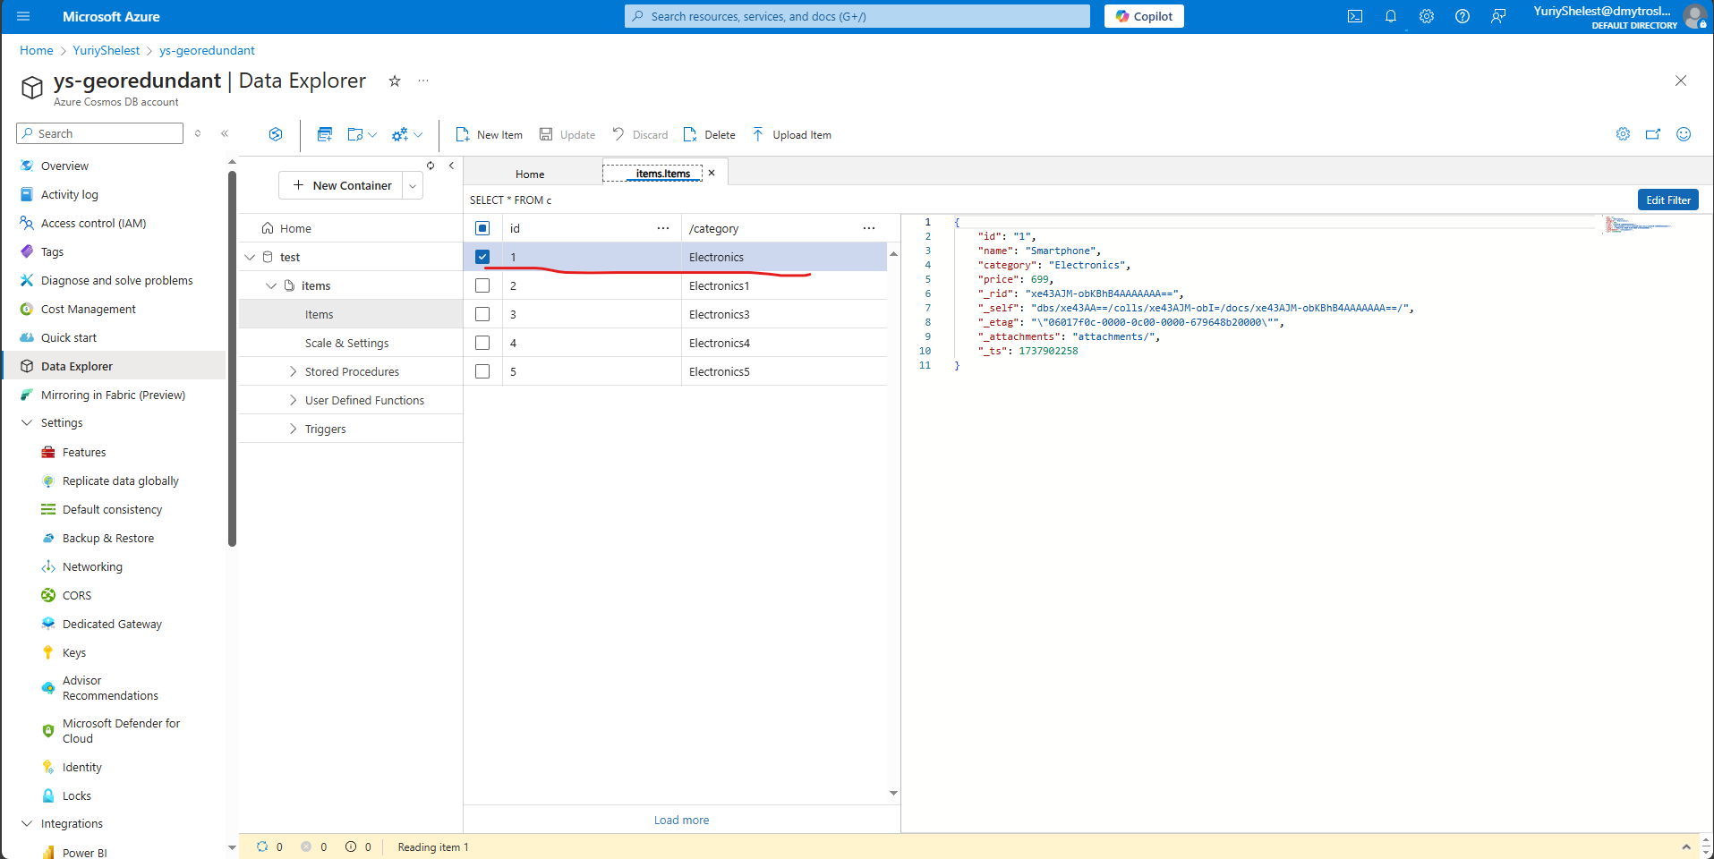

**4. Query Data in Cosmos DB:**

o Use SQL-like queries in the Data Explorer to retrieve data:

▪ Retrieve all documents: SELECT * FROM c 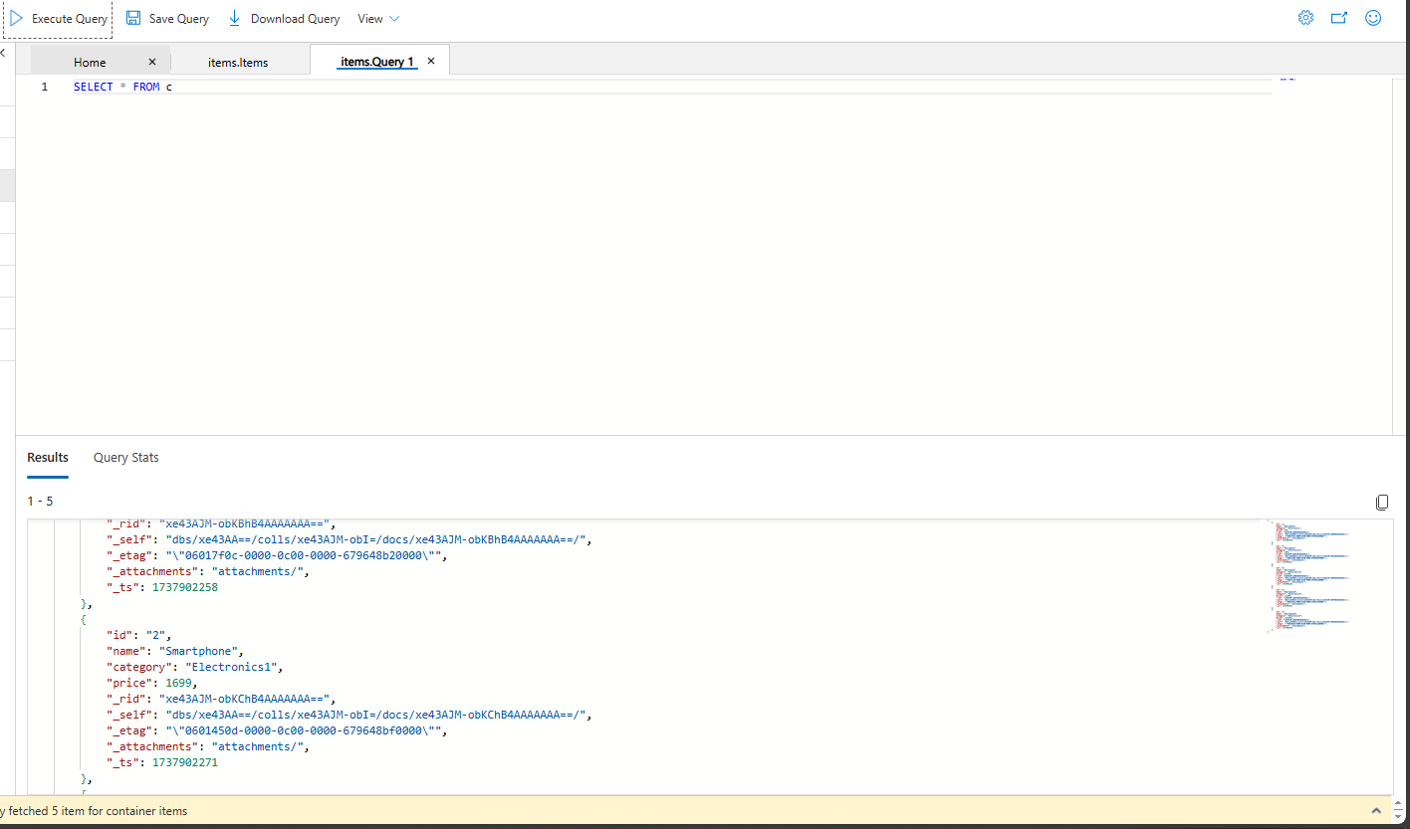

▪ Retrieve specific documents: SELECT * FROM c WHERE c.category = 'Electronics'

o Observe how the partition key affects query results. 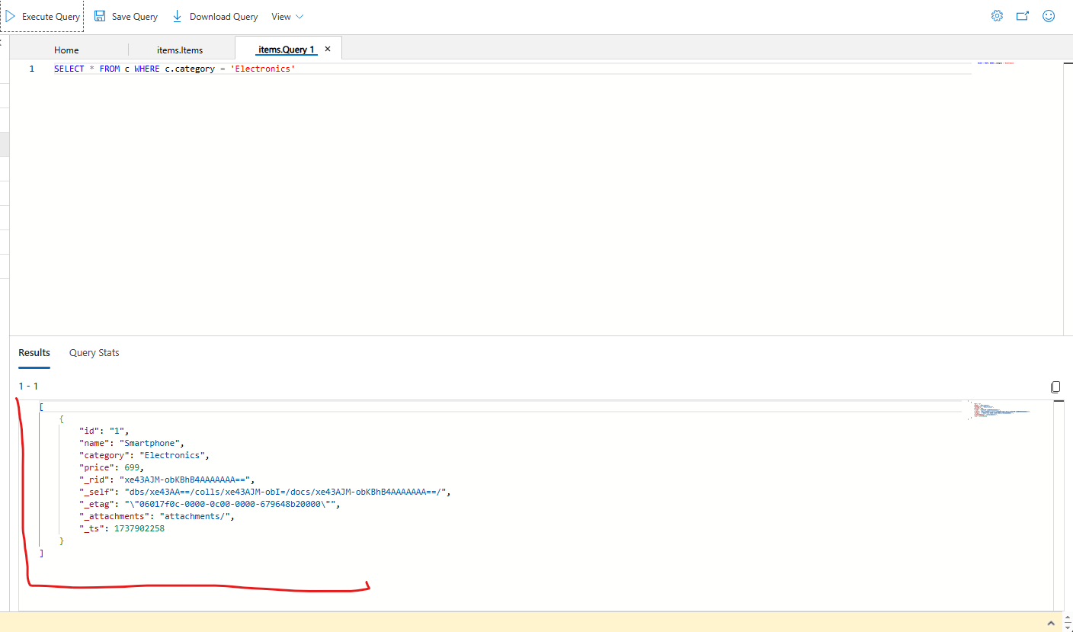

**5. Configure and Test Consistency Levels:**

o Review the available consistency levels in the Cosmos DB account: Eventual, Session, Consistent Prefix, Bounded Staleness, Strong. 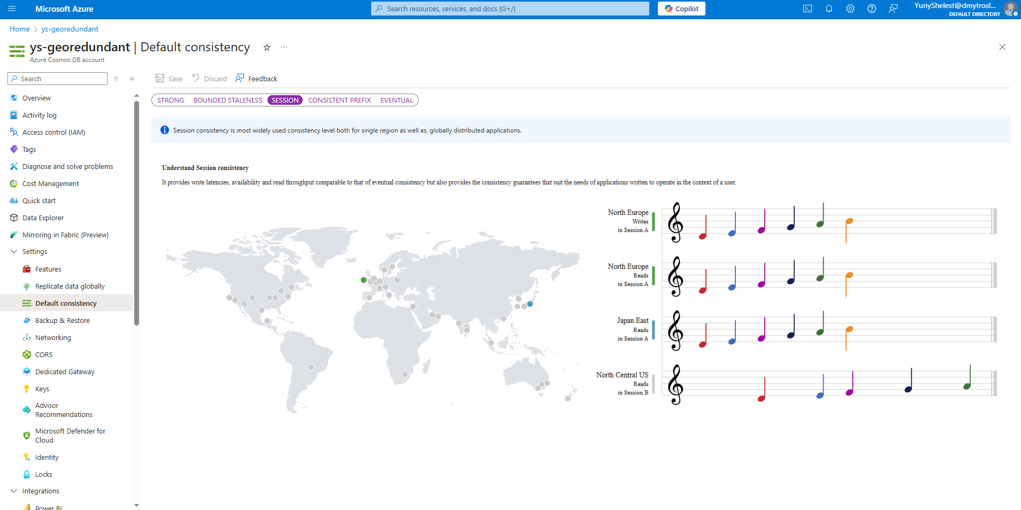

o Set the account-level consistency to "Session." 

o Perform a query or data operation and observe the impact on performance and latency. 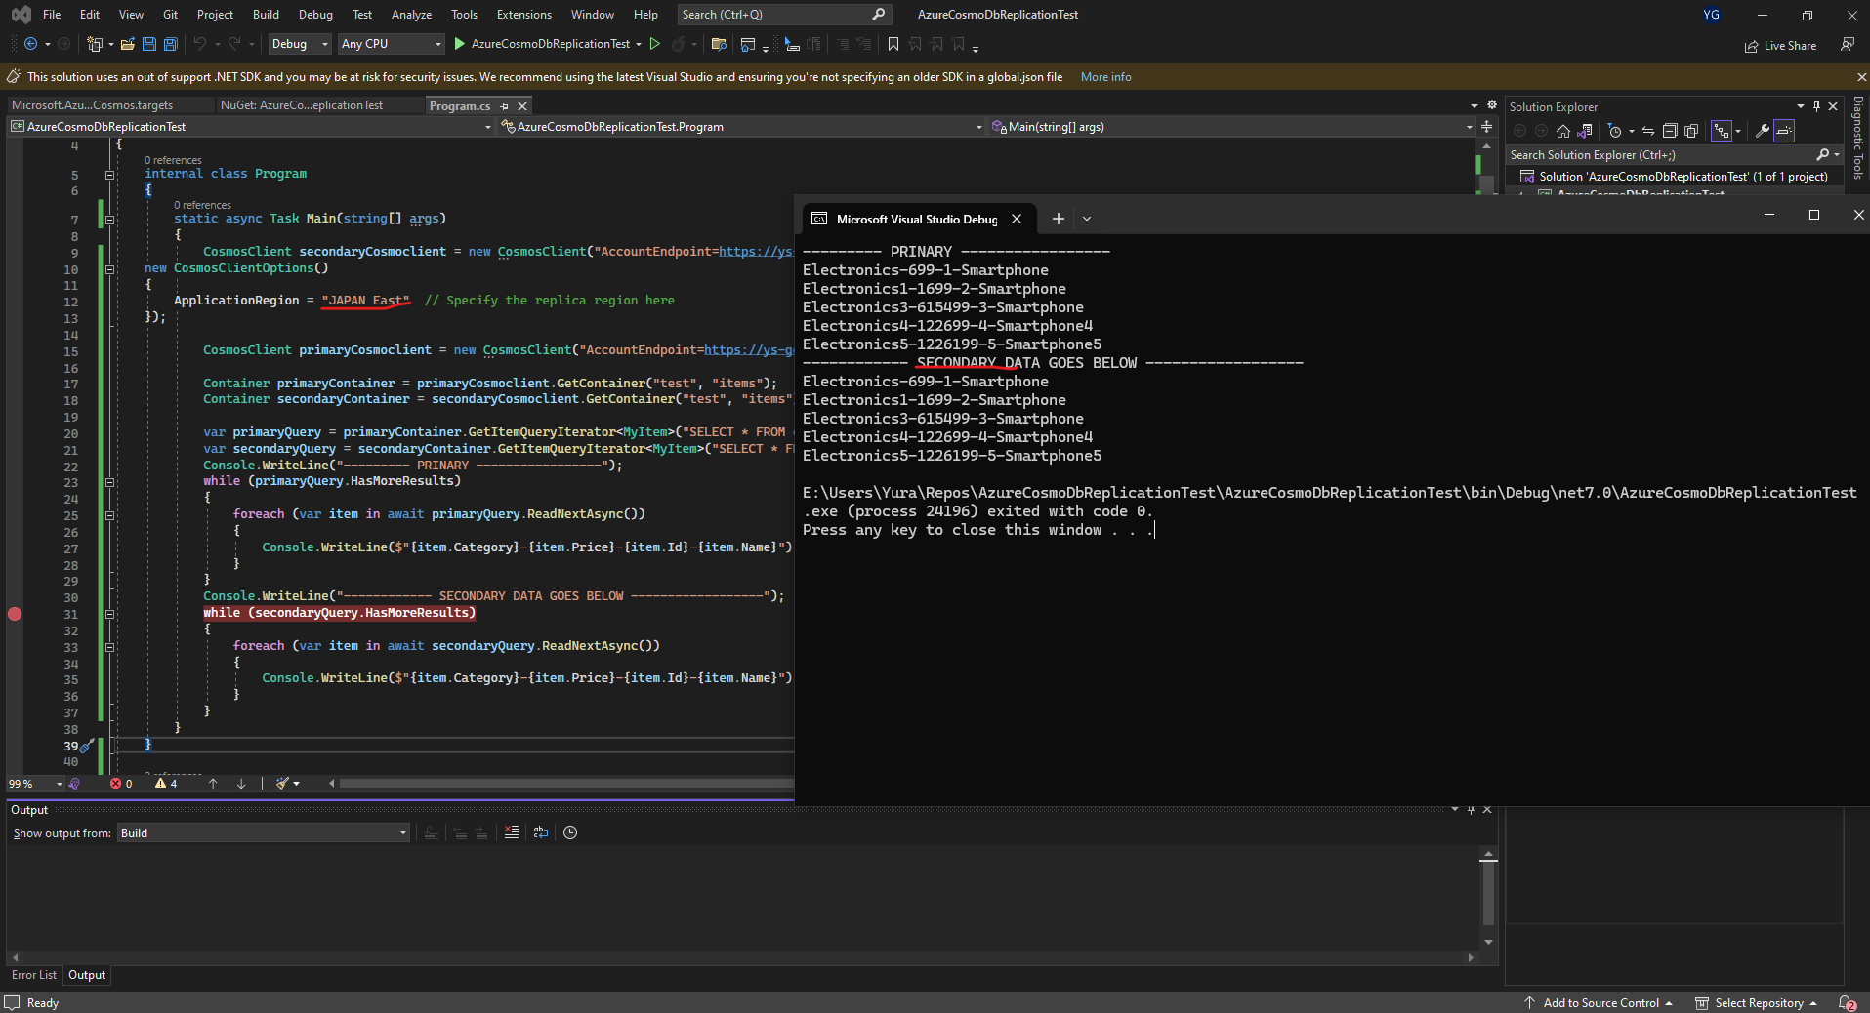

**6. Enable Global Distribution and Test Replication:**

o Enable multi-region replication by adding at least one additional region to the Cosmos DB account. 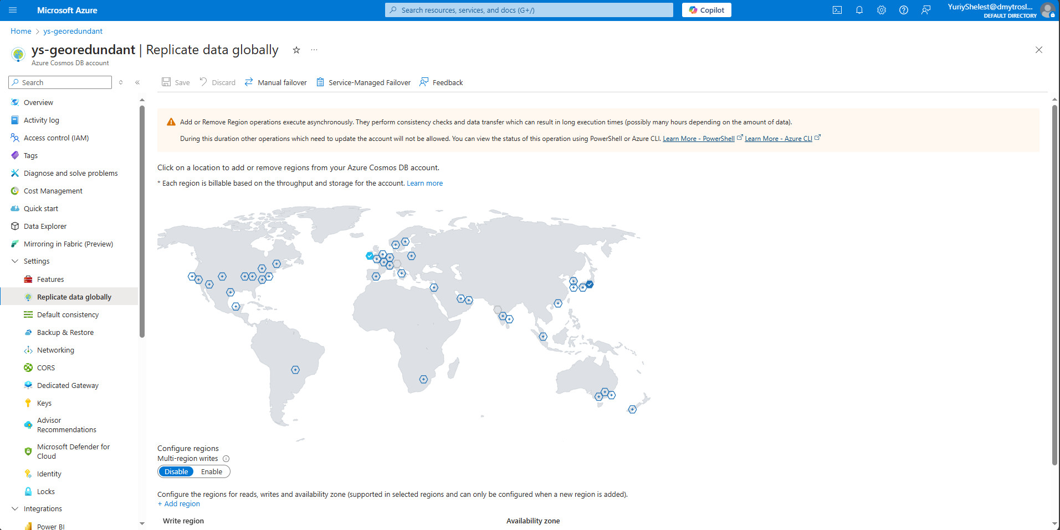

o Insert new data into the primary region and verify that it replicates to the secondary region. 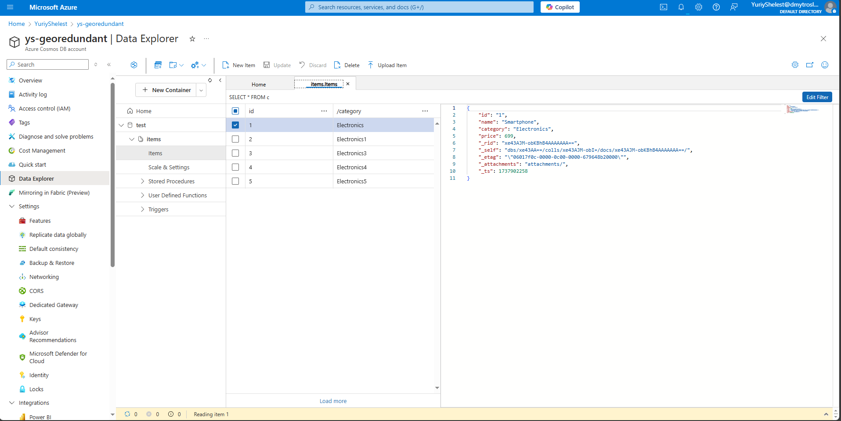

o Perform a manual failover and verify that the secondary region becomes the primary. 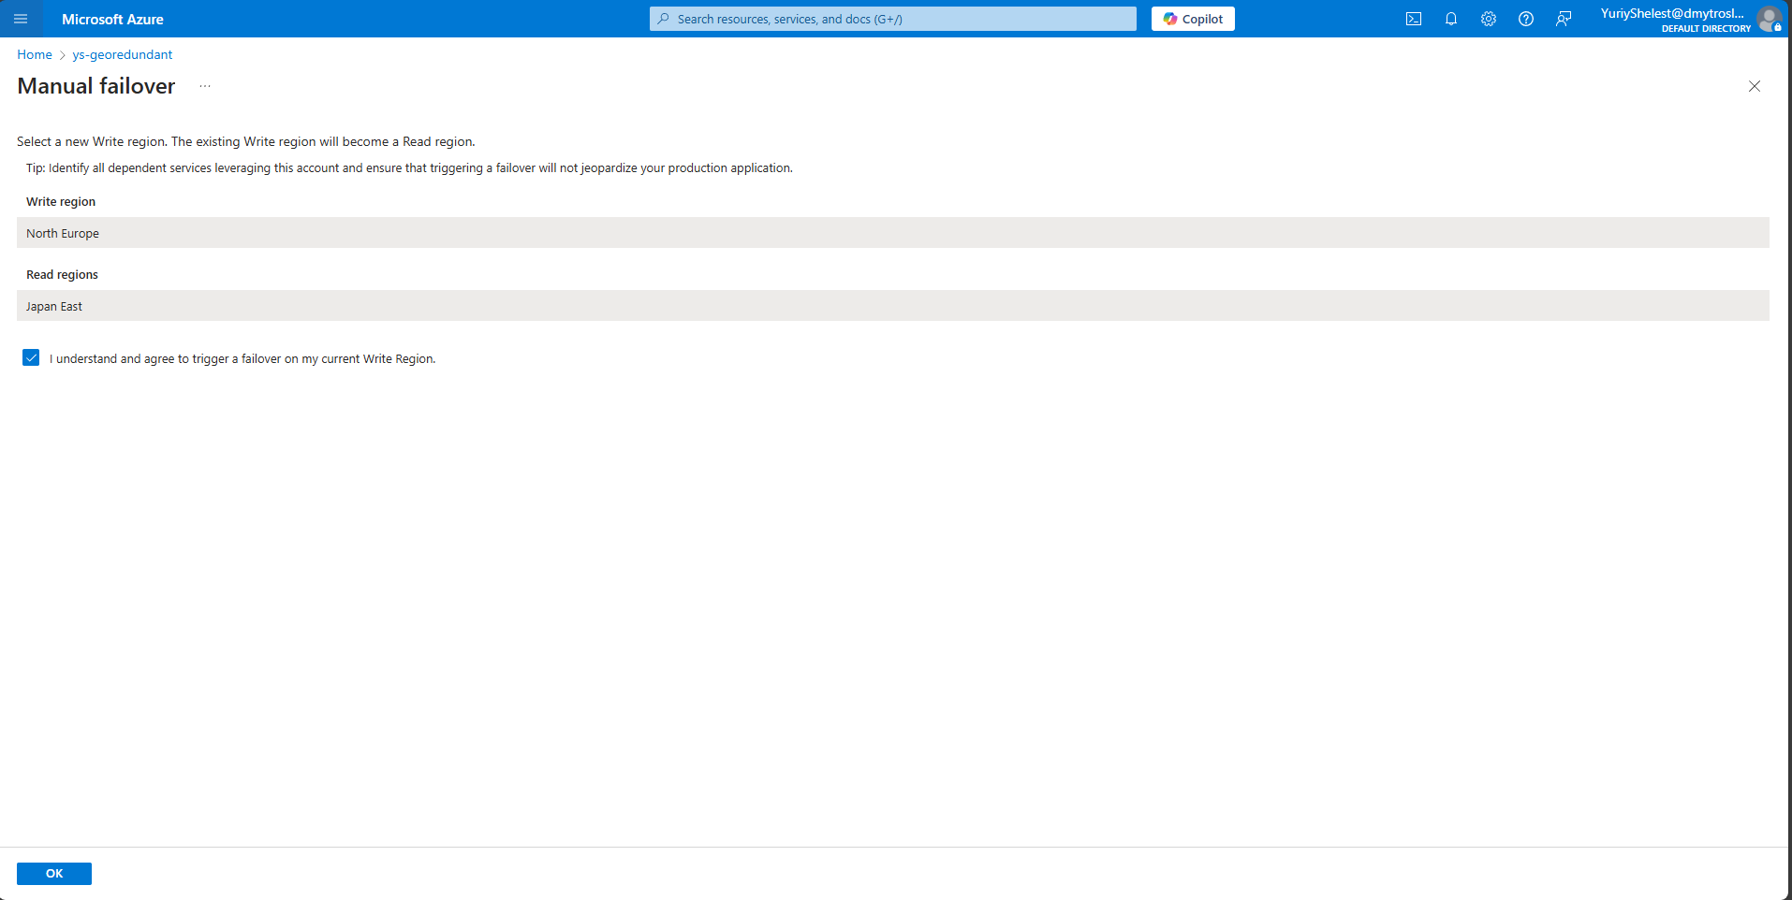

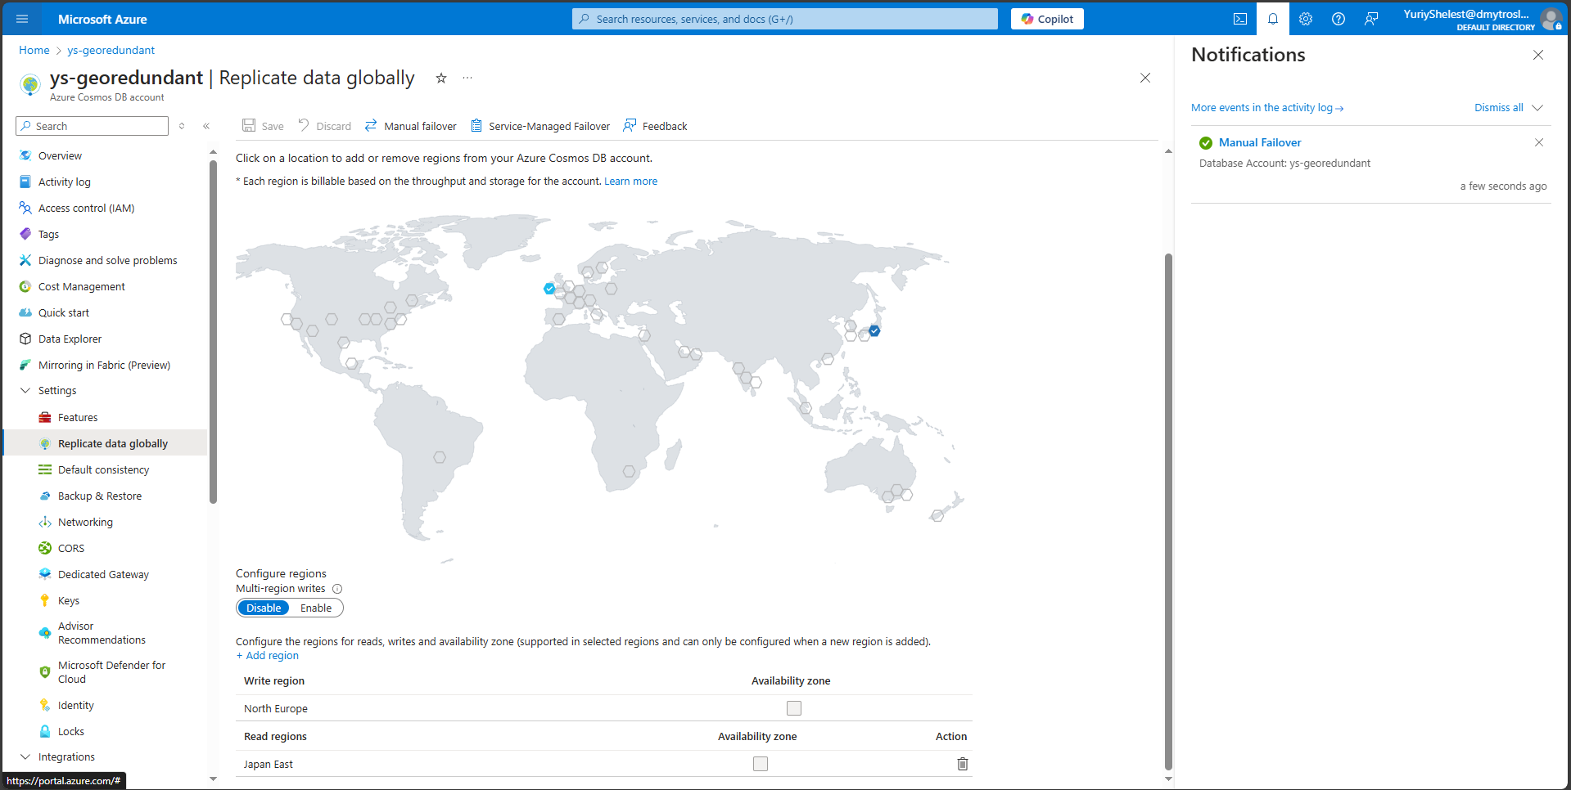

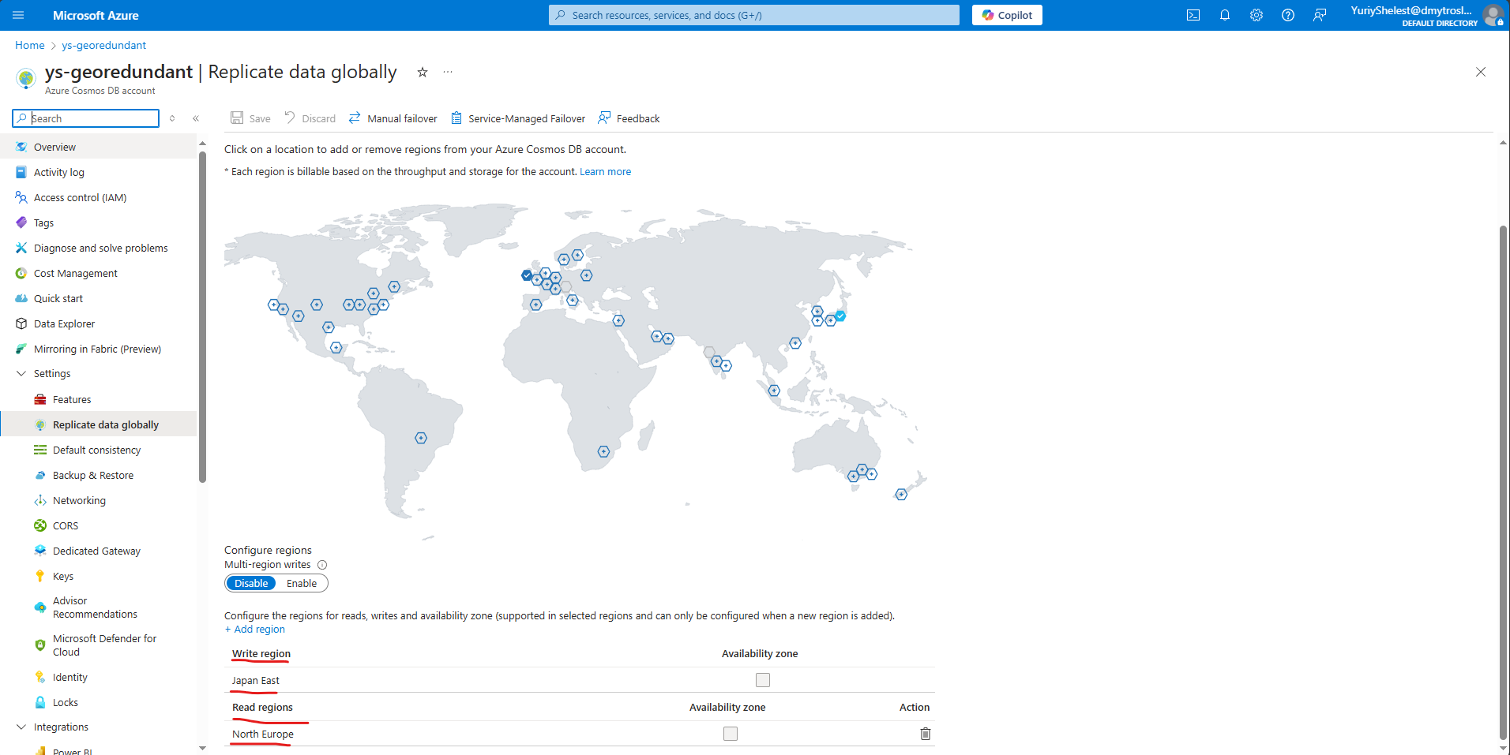

o Test data consistency and latency after failover.

Latency seems to be quick enough regardless, I would assume problems start with larger amounts of data or more regions/replicas